$Skriv ligningen her.$Microeconomics 2
Indholdsfortegnelse
Microeconomics 2 1
Preliminaries 3
Example of taking the bus or cycle depending on snow 3
Information levels 3
Strategy 4
Equilibrium analysis 5
Evaluation solution concepts 5
Evaluating outcomes 6
Example of two participants in a game show 6
Rationality and common knowledge 7
Experiment example from class 7
Dominant strategy equilibrium 8
Iterated elimination of strictly dominated pure strategies 9
Pinning down beliefs: Nash Equilibrium 11
Synergistic relationship 12
Expected payoff / Von Neumann-Morgenstern utility 14
Indifference principle 17
Mixed strategies (chapter 6 in the book) 17
Finite strategy sets 17
Beliefs and mixed strategies 18
Expected payoffs 18
Mixed-strategy Nash Equilibrium 19
Multiple equilibria: pure and mixed 20
Dynamics games of complete information (Preliminaries chapter 7) 22
The extensive form game 22
Game trees 22
Imperfect versus perfect information 24
Strategies and Nash equilibrium 24
Mixed versus behavioral strategies 25
Normal form representation of extensive form games 25
Nash Equilibrium and paths of play 25
Credibility and sequential rationality (chapter 8) 26
Sequential rationality and backward induction 26
Subgame-perfect Nash equilibrium: Concept 26
Subgame-perfect Nash equilibrium: Examples 27
Dynamic games of complete information (forelæsning) 28
Bargaining 30
Dictator game 30
Ultimatum game 30
Bargaining with counter-offer 32
Finite horizon bargaining 32
Alternating offer game (Rubinstein game) goes on forever, infinite 33
Repeated games slides 35
Infinitely repeated games 37
Infinitely repeated prisoner’s dilemma 37
Folk theorems 40
Friedman’s theorem 41
Static games of incomplete information 43
Bayesian games 47
Bayesian Nash equilibrium 47
Purification of mixed strategies 49
Auctions 50
Dynamic games of incomplete information 52
Signaling games 57

Preliminaries
GT: multiperson decision theory
Each persons utility possibly depends on actions of other agents.

Example of taking the bus or cycle depending on snow
With how long it takes you to go to school depending on transportation mode and chance of snow.
Time to schools | Snow (p) | No snow (1-p)
Cycle | 11 minutes | 3
Bus | 17 | 7
We can translate this into payoffs, utility. Get in the head of the decision maker and ask what he likes, we need to do this to form a meaningful game. For example an assumption could be that out decision maker likes shorter transport time, so we get the payoffs or utilities of (this is just numbers we made to show out player likes a shorter transport time)
Payoff of different scenario | Snow (p) | No snow (1-p)
Cycle | 2 | 4
Bus | 1 | 3

Battle of the sexes, BOS: a coordination game with conflict.
With two students we can have, where we then have payoffs as two different numbers
A/B | Cycle B | Bus B
Cycle A | 2, 3 | 0, 0
Bus A | 1, 1 | 3, 2
So we see that student A’s payoff is dependent on what student B chooses and vise versa.
They probably like travelling together. A prefers the bus, B prefers the bicycle.

Information levels
Static games of complete information: most fundamental games or environments. A set of players independently choose a once-and-for-all actions, causes realization of outcomes.
A mathematical summary of:
- Who is involved
- With which possibilities to act
- With which goals

Simultaneously and independently of each other does not have to be at the same time, but one cannot know about the decisions of the other.
Complete information game: all players understand the environment they are in in every way.
- Complete perfect information game: every move is observable. Do this could for example be chess, here you even have a protocol of what has happened so far, will be relevant when we look into dynamic games.
- Complete imperfect information game: cannot observe how the other players move. Think about a board game like poker where we all know the rules, you know your preferences of yourself and maybe the other players, but you cannot always observe their moves.
Incomplete information game: some crucial part of the games elements are not known to everybody. Something is missing. So something about the other individuals preferences might be missing.

Games of complete information:
- all the possible actions of all the players,
- all the possible outcomes,
- how each combination of actions of all players affects which outcome will materialize, and
- the preferences of each and every player over outcomes.
Common knowledge: an event is common knowledge if everyone knows the event and everyone knows that everyone know about the event and so on.
Normal form game simple version:
- A set of players.
- A set of actions for each player.
- A set of payoff functions for each player that give a payoff value to each combination of the players’ chosen actions.

Strategy
Strategy: a plan of action intended to accomplish a specific goal.
Pure strategy: a deterministic plan of action.
A profile of pure strategies: a particular combination of pure strategies chosen by all n players in the game.
A normal-form game includes three components as follows:
1. A finite set of players, $N=\{1,2,...,n\}$.
2. A collection of sets of pure strategies$, \{S_{1},S_{2},...,S_{n}\}.$
3. A set of payoff functions$,\{v_{1},v_{2},...,v_{n}\},$each assigning a payoff value to each combination of chosen strategies, that is, a set of functions $v_{i}:S_{1}×S_{2}×…×S_{n}→R$ for each $i∈N$.
So a normal form game is a triple of sets.
Finite game: a game with finite number of players, and a finite number of strategies for each player.
For two players matrix of finite game:
Rows Each row represents one of player 1’s strategies. If there are k strategies in $S_{1}$ then the matrix will have k rows.
Columns Each column represents one of player 2’s strategies. If there are m strategies in $S_{2}$ then the matrix will have m columns.
Matrix entries Each entry in this matrix contains a two-element vector $(v_{1}, v_{2}),$ where vi is player i’s payoff when the actions of both players correspond to the row and column of that entry.
Bi-matrix: shows payoffs for example for rock-paper-scissors game, so in a way it is two matrices, one with the payoff for each player.
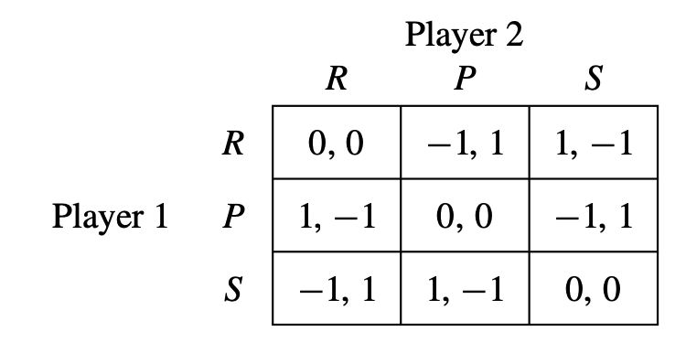
Solution concept: a method of analyzing games with the objective of restricting the set of all possible outcomes to the most reasonable ones.
Equilibrium: any one of the strategy profiles that emerges as one of the solution concepts predictions.

Equilibrium analysis
Setup:
1. Players are “rational”: A rational player is one who chooses his action, si ∈ Si , to maximize his payoff consistent with his beliefs about what is going on in the game.
2. Players are “intelligent”: An intelligent player knows everything about the game: the actions, the outcomes, and the preferences of all the players.
3. Common knowledge: The fact that players are rational and intelligent is common knowledge among the players of the game.
4. Self-enforcement: Any prediction(or equilibrium) of a solution concept must be self-enforcing.

Noncooperative game theory: any equilibrium must be self-enforcing. Each player has to be happy about their own choice given what the others choose.
About 80% of all games there are. We need to specify who are the players, what can they do, what information do they have at any given point? Even if they can communicate they cannot sign an agreement, cannot really commit to a price or something else. In noncooperative game theory there is no way to sign a binding contract, so if they agree on a higher price there must be something in the game that makes this possible. Everything that enables a corporation must come from the game.
Cooperative game theory: there is the assumption that people can make binding agreements, if we assume that people can agree on something the question is then what is a fair division of for example the gains? Normative exercise, niche.
Evolutionary game theory: coming from biology, studies how different behaviors multiply or get reduced thanks to evolutionary success. No more about thinking individuals but about hard wired ways for the animals to react in a larger group and how that group evolves.

Evaluation solution concepts
Existence: how often does it apply?
Applies to a wide variety of games, should apply generally.
Uniqueness: how much does it restrict behavior?
Needs to be meaningful, restrict the set of possible outcomes to smaller set of reasonable outcomes. Quite hard to reach.
Invariance: how sensitive is it to small changes?
So invariant to small changes. So if there are small changes in the payoff functions of the players. Needs to be a robust solution concept.

Evaluating outcomes
Socially undesirable: if there is a different outcome that would make some people better off without harming anyone else.
Pareto optimality: a strategy profile $s∈S$ Pareto dominates strategy profile $s^{'}∈S$ if $v_{i}\left(s\right)≥v_{i}\left(s^{'}\right)∀i∈N$ and $v_{i}\left(s\right)>v_{i}\left(s^{'}\right)$ for at least one $i∈N$ (in which case, we will also say that $s'$ is Pareto dominated by s). a strategy profile is Pareto optimal if it is not Pareto dominated by any other strategy profile.

Example of two participants in a game show
This is the Prisoner’s dilemma
The two characteristics to be a prisoner’s dilemma are:
- All players have a strictly dominant strategy.
- Outcome is Pareto-inferior: If they all choose their strictly dominant equilibrium of choosing the socially bad situation, they would be better off if they trusted the other person, if they could have coordinated.
They can in this example choose between getting $1000 themselves or to give $4000 to the other participant, so it is a better conclusion for both of them if they both chose to give the $4000 to the other person, but they do not trust each other and so it does not happen.
Their payoffs are then
Person A/Person B | Give me $1000 | Give the other $4000
Give me $1000 | 1000, 1000 | 5000, 0
Give the other $4000 | 0, 5000 | 4000, 4000
So the optimal for them must be to give themselves $1000 as they are then sure to get some amount of money, no matter what the other person does.
We assume they have the same utility for the money. They have a linear utility in the money.
Give me $1000 if better regardless of what the other person chooses.

Public good game: if each are given a sum of money, and then if a person pays to a total pot a larger amount than was paid in by the one person will be distributed to all the people in the experiment equally. But if the other people do not contribute anything then the person who contributed gets less, so it is smartest for everyone not to give anything to the pot as they cannot trust the other people.
Could for example depend on if you know the people, or if you can communicate and make binding contracts.

Rationality and common knowledge
Notation:
Payoff of player $i$ from a profile of strategies: $v_{i}\left(s\right)$ for $s=\left(s_{1},s_{2},…,s_{i},…,s_{n}\right)$
Actions chosen by the players who are not player $i$ are denoted by the profile
$$s_{-i}=\left(s_{1},s_{2},…,s_{i-1},s_{i+1},…,s_{n}\right)∈S_{1}×…×S_{i-1}×S_{i+1}×…×S_{n}$$
Shorthand notation:
$$S_{-i}=S_{1}×…×S_{i-1}×S_{i+1}×…×S_{n}$$
The set of all strategy sets of all players who are not player $i$.
$$s_{-i}∈S_{-i}$$
Is a particular possible profile of strategies for all players who are not player $i$.
Payoff of player $i$ from strategy s is
$$v_{i}\left(s_{i},s_{-i}\right), s=\left(s_{i},s_{-i}\right)$$
Strictly dominated strategies: $s_{i}^{'}$ is strictly dominated by $s_{i}$ if for any possible combination of the other players’ strategies $s_{-i}∈S_{-i}$ that
$$v_{i}\left(s_{i},s_{-i}\right)>v_{i}\left(s_{i}^{'},s_{-i}\right)∀s_{-i}∈S_{-i}$$
Also write $s_{i}≻_{i}s_{i}^{'}$. So $s_{i}^{'}$ is strictly dominated by $s_{i}$.
A rational player will never play a strictly dominated strategy.
$Δ\left(S_{i}\right)$: set of all probability distributions over $S_{i}$ ($=i^{'}smixed strategies$)
$σ_{i}∈Δ\left(S_{i}\right)$: a mixed strategy of $i$.
$σ,σ_{-i}$: analogous

Normal form, strategic form: of a game is the triplet $〈N,S,u〉$ specifying the players, their strategies and payoff functions.
The mixed extension of $〈N,S,u〉$, denoted $〈N,Σ,u〉$ with $Σ=Δ\left(S_{1}\right)×…×Δ\left(S_{n}\right)$ explicitly allows the use of mixed strategies, i.e. players can independently randomize over their pure strategies.

Experiment example from class
We have 3 people, they are all wearing a hat, they do not know the color of their hat, it can be either red or green but they do not know for themselves, but can see the other peoples hats.
We are told to start with that the hats are either red or green, now there is a public announcement that there is at least one red hat.
If the first two people do not know the color of their hat we then know that they can see at least one red hat, and so when we get to person 3 if the two people before could both see at least 1 red hat then person 3 must be wearing a red hat.
So the first person sees are red hat, the second person as well, not sure

Example from slides:
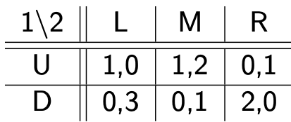
Eliminate the strictly dominated ones:
So first we rule our R as it is strictly dominated by M
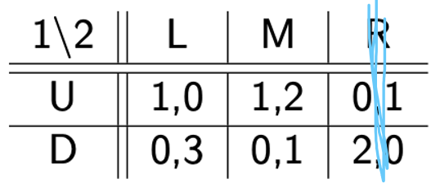
Then we rule out D as it is now strictly dominated by U
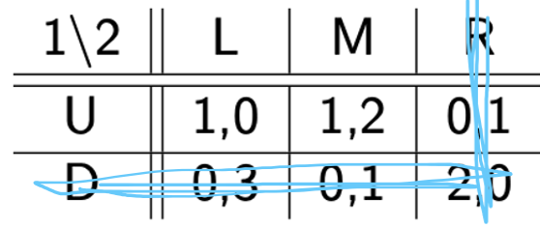
And then at last we rule out L as it is then strictly dominated by M
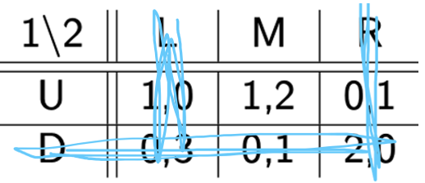
And so we get they will choose U and M

Dominant strategy equilibrium
Strictly dominant strategy: $s_{i}∈S_{i}$ is a strictly dominant strategy for $i$ if every other strategy of $i$ is strictly dominated by it, that is if
$$v_{i}\left(s_{i},s_{-i}\right)>v_{i}\left(s_{i}^{'},s_{-i}\right)∀s_{i}^{'}∈S_{i}, s_{i}^{'}≠s_{i} and all s_{-i}∈S_{-i}$$
Strict dominant strategy equilibrium: The strategy profile $s^{D}∈S$ is a strict dominant strategy equilibrium if $s_{i}^{D}∈S_{i}$ is a strict dominant strategy for all $i∈N$.
Note: the solution is not the payoffs but the strategies the players choose, so the set of actions.
Unique dominant strategy equilibrium: if the game $Γ=〈N,{\left\{S_{i}\right\}}_{i=1}^{n},{\left\{v_{i}\right\}}_{i=1}^{n} 〉$ has a strictly dominant strategy equilibrium $s^{D}$, then $s^{D}$ is the unique dominant strategy equilibrium.
Many games do not have a strict dominance solution.
Weak dominance: $s_{i}^{'}$ is weakly dominated by $s_{i}$ if for any possible combination of the other players’ strategies $s_{-i}∈S_{-i}$ that
$$v_{i}\left(s_{i},s_{-i}\right)≥v_{i}\left(s_{i}^{'},s_{-i}\right)∀s_{-i}∈S_{-i}$$
So it is only blødt større end.
Weakly dominant strategy: same idea as above, not a strict inequality always.
If a weakly dominant equilibrium exists it need not be unique.

Example of undominated and a mix of two
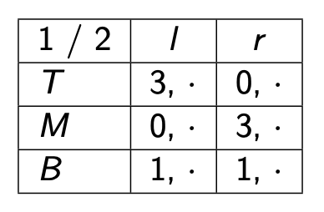
So here we see that B is undominated by T and M, they are not strictly better.
But if we could go $\left(\frac{1}{2},\frac{1}{2},0\right)$ then this would be better than B as it would then give us 1,5 no matter what player 2 chooses.

Iterated elimination of strictly dominated pure strategies
- A rational player will never play a dominated strategy.
- If a rational player has a strictly dominant strategy then he will play it.
Iterated elimination and common knowledge of rationality: rationality tells us which strategies will never be played.
Iterated elimination of strictly dominated strategies IESDS: players all know that the others might eliminate/not choose specific strategies and so we can minimize the actual possible plays perhaps until we have a solution.

Another example from class
1/2 | e | m | r
T | 1,0 | 1,2 | 0,1
M | 0,3 | 0,1 | 2,0
B | -1,5 | -1,3 | 1,4
One would never choose B here if one could choose M in this instance.
So we get
1/2 | e | m | r
T | 1,0 | 1,2 | 0,1
M | 0,3 | 0,1 | 2,0
B | -1,5 | -1,3 | 1,4
Now we eliminate r as it is strictly dominated by m
1/2 | e | m | r
T | 1,0 | 1,2 | 0,1
M | 0,3 | 0,1 | 2,0
B | -1,5 | -1,3 | 1,4
Now we rule out M and then we rule out e to get that out prediction is $\left(T,m\right)$
1/2 | e | m | r
T | 1,0 | 1,2 | 0,1
M | 0,3 | 0,1 | 2,0
B | -1,5 | -1,3 | 1,4
This was elimination of strictly dominated strategies IESDS

Let $S_{i}^{k}$ denote the strategy set of player $i$ that survives k round of IESDS. Define $S_{i}^{0}=S_{i}$ for each $i$, the original strategy set of player $i$ in the game.
Steps:
Step 1: Define $S_{i}^{0}=S_{i}$for each i, the original strategy set of player i in the game, and set k = 0.
Step 2: Are there players for whom there are strategies $s_{i}∈S_{i}^{k}$ that are strictly dominated? If yes, go to step 3. If not, go to step 4.
Step 3: For all the players $i∈N$, remove any strategies $s_{i}∈S_{i}^{k}$ that are strictly dominated. Set $k=k+1$, and define a new game with strategy sets $S_{i}^{k}$ that do not include the strictly dominated strategies that have been removed. Go back to step 2.
Step 4: The remaining strategies in $S_{i}^{k}$ are reasonable predictions for behavior.

Iterates-elimination equilibrium: any strategy profile that survives the process of IESDS.
Evaluation IESDS: when strictly dominated strategies exist, the process of IESDS is able to say something about how common knowledge of rationality restricts behavior.
Pareto optimality needs not be achieved by IESDS.

If for a game $Γ=〈N,{\left\{S_{i}\right\}}_{i=1}^{n},{\left\{v_{i}\right\}}_{i=1}^{n} 〉$ that $s^{⋆}$ is a strict dominant strategy equilibrium, then $s^{⋆}$ uniquely survives IESDS.

More examples
Example of IEWDS Iterated elimination of weakly dominated strategies
This is when we also go by strategies that are only weakly dominant, which does not always give the correct answers.
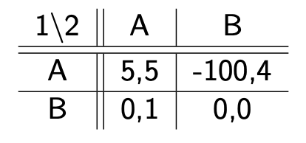
Here we would predict $\left(A,A\right)$ but person 1 might not like this as they could loose 100 instead if person 2 does not behave as we expect.

1/2 | e | c | r
T | 2,2 | 2,1 | 1,0
B | 2,1 | 2,2 | 0,2
At first we would eliminate B as it is weakly dominated by T, and then player 2 would eliminate r, but then player 1 is actually equally happy about T and B once r is not a probability. So this is not such a good example, we see why it is not enough for it to be weakly dominating to rule out a specific possibility.

For
1/2 | e | c | r
T | 1,1 | 1,1 | 0,0
B | 0,0 | 1,2 | 1,2
If we start by eliminating r then the outcome is either $\left(T,e\right)$ or $\left(T,c\right)$ but if we eliminate e first we get that it would be $\left(B,c\right)$ or $\left(B,r\right)$ I think?
So we see when we eliminate weakly dominated strategies we can get very different outcomes.

Weakly dominated strategies can very well be a part of an equilibrium.

Golden balls video example
I/N | split | steal
Split | 6800, 6800 | 0, 13600
steal | 13600, 0 | 0, 0
In the video they end up splitting, but it was almost more because of weird psychology.
In this example we have 3 Nash equilibrium all but the ones split, split as depending on if the other one chooses steal then the first person is irrelevant between their two options.

Level k reasoning: if I believe that the others are level 0(they have no clue strategically, and just pick a random number between 0 and 100) and so they pick a number at random, then the average is 50 so then I should pick 2/3*50.
If my peers are level 1 then I assume others are level 0 so average is 33 and so I would pick 2/3*33=22
If I am level 2 rational then I believe all others are at level 1 and I choose 2/3*22=16 ish.
So the higher a level you are at the lower one would guess.

Pinning down beliefs: Nash Equilibrium
In many games we cannot rule out enough, many things are reasonable. I believe that the other person will do this and that, and it is also reasonable to believe that the other person will do this.
Nash equilibrium: each player is playing a best response to their beliefs, players have correct beliefs. The pure strategy profile $s^{⋆}=\left(s_{1}^{⋆},s_{2}^{⋆},…,s_{n}^{⋆}\right)∈S$ is a Nash equilibrium if $s_{i}^{⋆}$ is a best response to $s_{-i}^{⋆}$ for all $i∈N$, that is
$$v_{i}\left(s_{i}^{⋆},s_{-i}^{⋆}\right)≥v_{i}\left(s_{i}^{'},s_{-i}^{⋆}\right)∀s_{i}^{'}∈S_{i} and all i∈N$$
Note: I think we would like to use u and not v as we are representing utility.
There needs to be no incentive to deviate from what I expect the others to do.
For an equilibrium there needs for me to be no incentive to deviate.
A Nash equilibrium becomes self enforcing if the people can talk beforehand and can come to an agreement, can trust each other I think?

Unique Nash equilibrium:
Consider a strategy profile $s^{⋆}=\left(s_{1}^{⋆},s_{2}^{⋆},…,s_{n}^{⋆}\right)$. If $s^{⋆}$ is either
1. a strict dominant strategy equilibrium,
2. the unique survivor of IESDS, or
3. the unique rationalizable strategy profile,
then $s^{⋆}$is the unique Nash equilibrium.

Finding a Nash equilibrium: for matrix and two players
Step 1: find the strategy for player 2 that is best for each possible strategy for player 1 and underline.
Step 2: do the same for player 1 depending on player 2, and overline these.
Step 3: if an entry is both underlined and overlined it is the outcome of a Nash equilibrium in pure strategies.

For $ϵ=0$ (prices can be any real number) there is a unique Nash equilibrium: $p_{1}?p_{2}=c$.
Median voter theorem: if voters are different from one another along a single dimensional preference line, and if each prefers his own political location then the political platform located at the median voter will defeat any other platform in a simple majority vote.

Nash equilibrium example
Where is the Nash equilibrium for this example?
1/2 | l | m | r
T | 0,4 | 4,0 | 5,3
M | 4,0 | 0,4 | 5,3
B | 3,5 | 3,5 | 6,6
It is $\left(B,r\right)$ as they have the best possible strategy depending on what the other player does, and then the one where they have the same response, just like it is explained above.

1/2 | l | m | r
T | 0,4 | 4,0 | 5,3
M | 4,0 | 0,4 | 5,3
B | 3,5 | 3,5 | 6,6
So we find where their overlap of best responses are.
If we draw it se see:
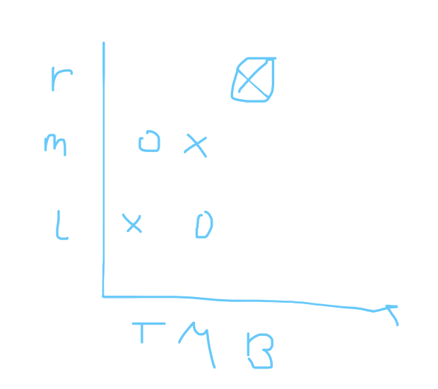

Synergistic relationship
- Two individuals are involved in a synergistic relationship
- If both individuals devote more effort to the relationship, they are both better off
- For any given effort level of individual j, the return to individual i’s effort first increases and then decreases
- Player i′s preferences are:
$$e_{i}\left(c+e_{j}-e_{i}\right)$$
where $e_{i}$ is i’s effort level, $e_{j}$ is the other’s effort level and $c>0$ is a constant
- Players choose their effort simultaneously
So they are both better off if they both put in more effort, but one is worse off if they are the only person to put in effort.
Player $i$’s best response correspondence is
$$B_{i}\left({\hat{e}}_{j}\right)∈\arg{\max_{e_{i}}}e_{i}\left(c+{\hat{e}}_{j}-e_{i}\right)$$
So we get
$$B_{i}\left({\hat{e}}_{j}\right)=\frac{c+{\hat{e}}_{j}}{2}$$

Best response diagram: I put my players strategy spaces on the axis and so we get
So we see they have a Nash equilibrium where the two pass each other.
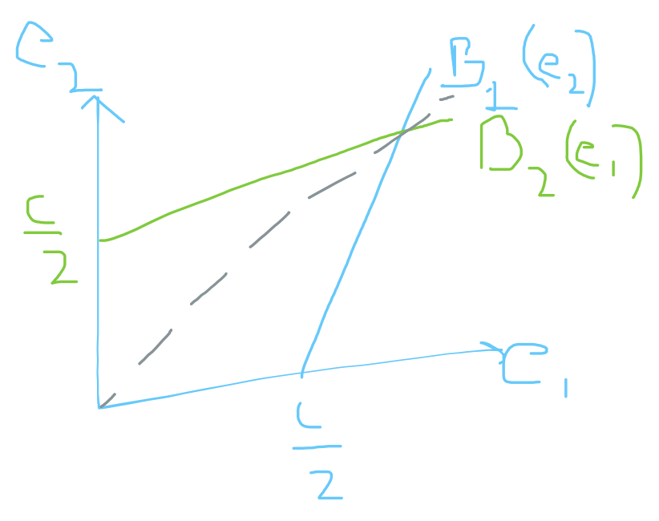
We set the two equal to each other, or we exploit the symmetry of the two. So instead of pretending they do something different use that in equilibrium the planned option(what they actually do) must be the same, so we get a unique answer in this case.
This is a game of strategic complements.
Strategic complements: the more I do the more you want to do, the more gin you want the more tonic one would also like.
We can see this in the diagram from the fact that the best responses are moving upwards, upwards sloping best responses.
In the pot with the public good if other people put more in we would like to put less in.

Note: If you have n players sometimes the only way to find the Nash equilibrium is to guess and verify.

Matching pennies example, Lottery
1 \ 2 | North | South
North | 1, -1 | -1, 1
South | -1, 1 | 1, -1
The best way to proceed here is to mix, to apply randomization as one is best off when they go the same way and one is best off if they go different ways.
Try to randomize equally among the 3 pure options.
So we get that the robber is 1 and the policeman is 2 so the robbers payoff from running north if the policeman goes either way with probability 0,5 for each. So for the robber we get
$$Payoff_{robber}\left(north\right)=\frac{1}{2}·1+\frac{1}{2}·\left(-1\right)=0$$
So the payoffs are not certain for the robber as they depend on the coin toss of the police. So this makes it a lottery, 50% chance of winning and 50% change of loosing.

- A simple lottery over outcomes definition
A simple lottery over outcomes $X=\left\{x_{1},x_{2},…,x_{n}\right\}$ is defines as a probability distribution $p=\left(p\left(x_{1}\right),p\left(x_{2}\right),…,p\left(x_{n}\right)\right)$, where $p\left(x_{k}\right)≥0$ is the probability that $x_{k}$ occurs and $\sum_{k=1}^{n}{p\left(x_{k}\right)}=1$.

Expected payoff / Von Neumann-Morgenstern utility
Single person decision theory:
- Complete
- Transitive

Lotteries
If the lottery has expected value of 0 it is fair.

- Expected payoff - the finite case
Let $u(x)$ be the player’s payoff function over outcomes in $X=\{x_{1},x_{2},...,x_{n}\},$ and let $p=(p_{1},p_{2},...,p_{n})$ be a lottery over$X$ such that $p_{k}=Pr\{x=x_{k}\}.$ Then we define the player’s expected payoff from the lottery p as
$$E\left[u\left(x\right) | p\right]=\sum_{k=1}^{n}{p_{k}u\left(x_{k}\right)}$$

Example with try to win luxury holiday vs buy used camera
Arrange lottery prices in order of desirability, so we get
Loosing last
Buying the camera in the middle
Winning the vacation at the top

If we are indifferent if the probability of winning the vacation is $π=0,1$ then we get
$$u\left(camera\right)=0,1·u\left(holiday\right)+0,9·u\left(loosing 100kr\right)=0,1$$
So the utility of the camera is 0,1 as it is what makes us indifferent between the vacation or the camera.
Written generally we get
$$U\left(x_{i}\right)=π_{i}·U\left(x_{n}\right)+\left(1-π_{i}\right)U\left(x_{1}\right)$$
So we have $x_{n}$ as it is the best outcome and $x_{1}$ as it is the worst outcome when we arrange them by desirability.

Von Neumann-Morgenstern continuity axiom
For any three lotteries $I_{1}≻I_{2}≻I_{3}∈Δ\left(X\right)$ $I_{1}$ and $I_{3}$ can be mixed such that
$$α·I_{1}+\left(1-α\right)·I_{3}≻I_{2}$$
And
$$I_{2}≻βI_{1}+\left(1-β\right)·I_{3}$$
With $α,β∈\left(0,1\right)$.

Von Neumann-Morgenstern independence axiom
For any two lotteries $I_{1}≻I_{2}∈Δ\left(X\right)$, the ranking does not change by mixing both with the same third lottery $I_{3}$.

Example, on the blackboard
Check for
A \ B
 | 2,1 | 0,0
 | 0,0 | 1,2
Are these two the same?

- This is ordinarily equivalent, on top of this is is also equivalent in the Von Neumann-Morgenstern sense as we should be able to apply the transformations for A $V_{A}\left(u\right)=2·u_{A}$ and for B we apply $V_{B}\left(u\right)=3·u_{B}-3$
A \ B
 | 4,0 | 0,-3
 | 0,-3 | 2,3

- In this one we see it is ordinally equivalent, but can be make a transformation so $a·u_{i}+b_{i}, a>σ$. So we cannot make a transformation like we did above.
A \ B
 | 3,2 | 0,1
 | 1,0 | 1,4

Example - a pure coordination game
1 \ 2 | Cafe | Library
Café | 3,3 | 0,0
Library | 0,0 | 1,1
So we have two pure strategy Nash-equilibriums.
Games usually have an odd number of equilibria, has something to do mathematically with where they can arrive so to speak, fixed points in a diagram.
We cannot go from a lower left corner to an upper right corner without crossing a line $x=f\left(x\right)$ without crossing it an uneven number of times
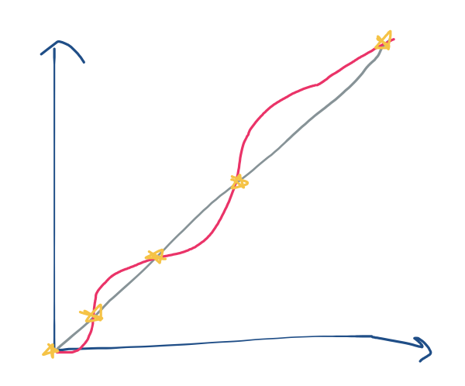
I think we need something about which side we start and end on? Otherwise it should not be very difficult, but it we have a “vandret linje” then it becomes uneven always when going from bottom left corner to top right.

General probability function for the café/library example
The probabilities for ending up in the different metrics makes this a problem of
 | $$〈q〉$$ | $$〈1-q〉$$
$$〈p〉$$ | $$p·q$$ | $$p·\left(1-q\right)$$
$$〈1-p〉$$ | $$\left(1-p\right)·q$$ | $$\left(1-p\right)·\left(1-q\right)$$
Now we can use this to look at if they both randomize we look at their probabilities with the outcomes from above (like on slides)

So we see we have 3 equilibriums, pure library, pure café or a mixed one with $p=\frac{1}{4}$ for the library for both of them.
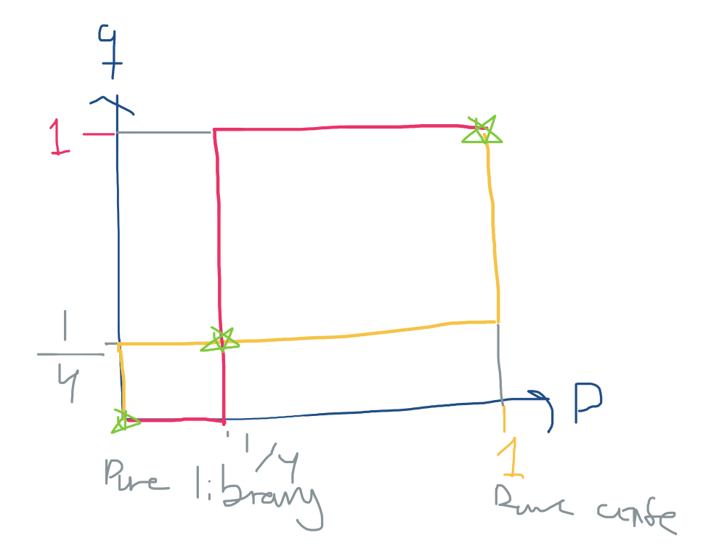
$$BR_{1}\left(q\right)=\left\{\begin{aligned}p=0, q<\frac{1}{4} \\ p=\left[0,1\right], q=\frac{1}{4} \\ p=1, q>\frac{1}{4}\end{aligned}\right.$$
$$BR_{2}\left(p\right)=\left\{\begin{aligned}q=0, p<\frac{1}{4} \\ q=\left[0,1\right], p=\frac{1}{4} \\ q=1, p>\frac{1}{4}\end{aligned}\right.$$

Indifference principle
The Eq, $q^{⋆}$ makes player 1 indifferent between his pure strategy:
$$u_{1}\left(cafe, q\right)=u_{1}\left(library,q\right)$$
So he becomes indifferent between which one he is going to.
For our example we get
$$3·q+0·\left(1-q\right)=0·q+1·\left(1-q\right)⇒q^{⋆}=\frac{1}{4}$$
Using this indifference principle can be a quick way to get these results in 2 by 2 players, or for multiple players if the games a symmetrical enough.

Example from class
Where we would like to implement the indifference principle
A\B | l | r
u | 2,2 | 8,1
d | 5,3 | 1,7
Go to the other players utility and take the difference, so we get
$$Δ_{l}=5-2=3, Δ_{r}=8-1=7$$
And so we use this at the opposite top, cross them over and normalize it to get the correct mixing probabilities
 | $$q=7/10$$ | $$1-q=3/10$$
$$p=\frac{4}{5}$$
$$1-p=\frac{1}{5}$$
It only works in 2 by 2 games.

Mixed strategies (chapter 6 in the book)

Finite strategy sets
Mixed strategy: Let $S_{i}=\{s_{i1}, s_{i2}, . . . , s_{im}\}$ be player i’s finite set of pure strategies. Define $ΔS_{i}$ as the simplex of $S_{i}$, which is the set of all probability distributions over $S_{i}$. A mixed strategy for player i is an element $σ_{i}∈ΔS_{i}$, so that $σ_{i}=\{σ_{i}(s_{i1}), σ_{i}(s_{i2}), . . . , σ_{i}(s_{im}))$ is a probability distribution over $S_{i}$, where $σ_{i}\left(s_{i}\right)$ is the probability that player i plays $s_{i}$.

So it is a probability distribution of his pure strategies.
$S_{i}$ must satisfy:
- $σ_{i}\left(s_{i}\right)≥0$ for all $s_{i}∈S_{i}$ and
- $\sum_{s_{i}∈S_{i}}{σ_{i}\left(s_{i}\right)}=1$

In the support of a mixed strategy
So it is has a probability larger than 0 in a specific mixed strategy of being chosen.
Definition: Given a mixed strategy $σ_{i}(·)$ for player i, we will say that a pure strategy $s_{i}∈S_{i}$ is in the support of $σ_{i}(·)$ if and only if it occurs with positive probability, that is, $σ_{i}\left(s_{i}\right)>0$.

A mixed strategy is a cumulative distribution: Let $S_{i}$ be player i’s pure-strategy set and assume that $S_{i}$ is an interval. A mixed strategy for player i is a cumulative distribution function $F_{i}:S_{i}→\left[0,1\right]$, where $F_{i}\left(x\right)=\operatorname{Pr}\left\{s_{i}≤x\right\}$. If $F_{i}\left(·\right)$ is differentiable with density $f_{i}\left(·\right)$ then we say that $s_{i}∈S_{i}$ is in the support of $F_{i}\left(·\right)$ if $f_{i}\left(s_{i}\right)>0$.

For a candidate for mixed NE check:
- It is not profitable for any player I to deviate from $σ_{i}$ to some pure strategy $s_{i}^{'}$ and
- That each player I is indeed indifferent between all $s_{i}∈supp\left(σ_{i}\right)$.
Note: if $supp\left(σ_{i}\right)=S_{i}$ we only need to check number 2.

Beliefs and mixed strategies
Belief: A belief for player i is given by a probability distribution $π_{i}∈ΔS_{-i}$ over the strategies of his opponents. We denote by $π_{i}\left(s_{-i}\right)$ the probability player i assigns to his opponents playing $s_{-i}∈S_{-i}$ .
So a probability distribution over the strategies of his opponents.

Expected payoffs
Expected payoff of player i: The expected payoff of player I when he chooses the pure strategy $s_{i}∈S_{i}$ and his opponents play the mixed strategy $σ_{-i}∈ΔS_{-i}$ is
$$v_{i}\left(s_{i},σ_{-i}\right)=\sum_{s_{-i}∈S_{-i}}{σ_{-i}\left(s_{-i}\right)v_{i}\left(s_{i},s_{-i}\right)}$$
The payoff of player I when he chooses the mixed strategy $σ_{i}∈ΔS_{i}$ and his oppnents play the mixed strategy $σ_{-i}∈ΔS_{-i}$ is
$$v_{i}\left(σ_{i},σ_{-i}\right)=\sum_{s_{i}∈S_{i}}{σ_{i}\left(s_{i}\right)v_{i}\left(s_{i},σ_{-i}\right)}$$
All pay auction: a game where two players can bid for a dollar, they can bid any positive amount of money, both of them have to pay their bit no matter if they win it or loose it, the highest bid wins.

Mixed-strategy Nash Equilibrium
More general definition of the Nash equilibrium: the mixed strategy profile $σ^{⋆}=\left(σ_{1}^{⋆},σ_{2}^{⋆},…,σ_{n}^{⋆}\right)$ is a Nash equilibrium if for each player $σ_{i}^{⋆}$ is a best response to $σ_{-i}^{⋆}$. That is, for all $i∈N$
$$v_{i}\left(σ_{i}^{⋆},σ_{-i}^{⋆}\right)≥v_{i}\left(σ_{i}^{ },σ_{-i}^{⋆}\right) , ∀σ_{i}∈ΔS_{i}$$
So we need player $i$ to be making one of his best strategies when his opponents are choosing some $σ_{-i}^{⋆}$.
What strategy to choose when multiple are equally as good?
If $σ^{⋆}$ is a Nash equilibrium, and both $s_{i}$ and $s_{i}^{'}$ are in the support of $σ_{i}^{⋆}$, then
$$v_{i}\left(s_{i},σ_{-i}^{⋆}\right)=v_{i}\left(s_{i}^{'},σ_{-i}^{⋆}\right)=v_{i}\left(σ_{i}^{⋆},σ_{-i}^{⋆}\right)$$
So they are all the same.

- For when there are more than 2 pure strategies( 3x3) and so forth
About mixed strategies: there can be no Nash equilibrium in which one player plays a pure strategy and the other mixes. (so they both need to do the same thing)
More: there can be no Nash equilibrium in which at least one player mixes only between two pure strategies. (so they need to mix between all of the strategies)

- Example of mixed strategy
 | l | c | r
u | 0,3 | 4,0 | 0,2
d | 2,1 | 2,6 | 1,4
There are not pure strategy equilibriums.
Now look at
 | l $〈q_{1}〉$ | c $〈q_{2}〉$ | r $〈q_{3}=1-q_{1}-q_{2}〉$
u $〈p〉$ | 0,3 | 4,0 | 0,2
d $〈1-p〉$ | 2,1 | 2,6 | 1,4
Possibilities:
- Mix l and c
Mix l and c here we would get for player 2 $q_{1}=\frac{1}{2}, q_{2}=\frac{1}{2}$ to make player 1 indifferent. Is this $p^{⋆}=$ $3·p+\left(1p\right)=6·\left(1-p\right)$ to be indifferent between l and c, this gives us $p=\frac{5}{8}$. So if it was only a 2x2 game we would be done already, but we also need to check about the deviation to pure strategies.
$$u_{2}(\left(p,\left(1-p\right);l\right)=\frac{9}{4}=u_{2}·\left(\left(p,1-p\right);c\right)$$
Is there an incentive to deviate and play r instead?
$$u_{2}\left(\left(p,\left(1-p\right)\right);r\right)=2·\frac{5}{8}+4·\frac{3}{8}=\frac{11}{4}$$
So there is a incentive to deviate to just playing r, and so it is not a mixed Nash equilibrium.

- Mix l and r
So we would leave out c. then player 1 would never play up. As for u player 1 gets 0 for both l and r and so this would mean that if we leave out c player 1 would never play u.
So there is no mixture as player 1 then prefers d.

- Mix c and r
As for player 1 we have a difference of 2 between the two outcomes in c, and a difference of 1 in the outcomes of r, so we would get $q_{2}=\frac{1}{3}, q_{3}=\frac{2}{3}$. We set $p=\frac{1}{2}$.
So now we need to check for incentive to deviate to the pure strategy of l. so we check
$$u_{2}\left(\left(0,\frac{1}{2},\frac{1}{2}\right),c\right)=3, u_{2}\left(\left(0,\frac{1}{2},\frac{1}{2}\right),l\right)=2$$
So there is no incentive to deviate from the mixture and so this is a mixed strategy Nash equilibrium.
$$NE=\left(\left(\frac{1}{2},\frac{1}{2}\right);\left(0,\frac{1}{3},\frac{2}{3}\right)\right)$$
So player 1 is $\left(\frac{1}{2},\frac{1}{2}\right)$ and player 2 is $\left(0,\frac{1}{3},\frac{2}{3}\right)$ in the Nash equilibrium.

- Player 2 mixes between all 3 options l, c and r
There is no mix for player 2 that makes player 1 indifferent between u and d.

Multiple equilibria: pure and mixed
Mixed-strategy equilibria need not be unique when they exist. They can have both pure strategies and mixed strategies, and when has pure strategies mostly also has mixed strategies.

- Bystander effect example
$n$ people able to help, either help or not, two actions
Payoffs:
- 0 if no one helps
- $v-c$ if you help (c is cost of helping)
- $v$ is someone else helps
$v>c>0$ (so it is better to help than not, but always better if someone else helps)
If only 1 person helps then no one has any incentive to deviate, if more people help people have incentive to deviate, and if not one else people have incentive to deviate and help.
So the Nash Equilibrium are the n different versions where exactly one person helps.

Expected utility from “help” is $v-c$. Expected utility from “don’t help” is
$$0·\operatorname{Pr}\left\{no one else calls\right\}+v·\operatorname{Pr}\left\{at least one other person calls\right\}$$
$$\frac{c}{v}=\operatorname{Pr}\left\{no one else calls\right\}={\left(1-p\right)}^{n-1}$$
So
$$p^{⋆}=1-{\left(\frac{c}{v}\right)}^{\frac{1}{n-1}}$$
So as n gets bigger the probability of calling goes down. If there are more people we more and more believe someone else will make the call.

- One more method for dealing with games like 2xm or mx2 games (the goalpost method) this is also an example
We have
 | $$l 〈q〉$$ | $$r 〈1-q〉$$
C | 1,2 | 0,0
S | 0,0 | 2,1
B | -1,4 | 3,1

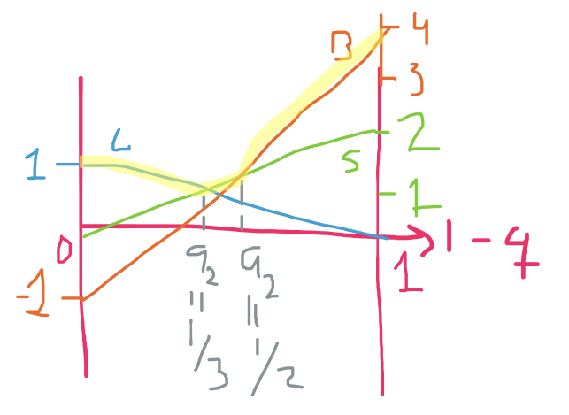
We do not care for B and C mixed as we see it is better to only do S as it is above the intersection.
So we have for mixing between C and S:
$$NE_{q_{2}=\frac{1}{3}}:\left(\left(\frac{1}{3},\frac{2}{3},0\right);\left(\frac{2}{3},\frac{1}{3}\right)\right)$$
We have the first one(for player 1) because
The difference for player 2 when player 1 plays C is 2, and the difference for player 2 when player 1 plays S if 1. And so when we have a total difference of 3 if we add them together then the one with a difference of 2 get 1/3 and the one with a difference of 1 gets 2/3. And we are not mixing with B here so it is just 0.
For mixing between S and B:
$$NE_{q_{2}=\frac{1}{2}}:\left(\left(0,\frac{3}{4},\frac{1}{4}\right);\left(\frac{1}{2},\frac{1}{2}\right)\right)$$
So we see there is a difference of 1 for S and 3 for B and so we get ¾ for S and ¼ for B.

Mixed strategy NE
- A truly mixed NE is never strict: in fact, all players are indifferent between (receive the same payoff from) all their actions played with positive probability.
- For given $σ_{-i}^{⋆}$, $i$ would not suffer from being restricted to $S_{i}$ rather than $Δ\left(S_{i}\right)$. But only for given $σ_{-i}^{⋆}$!

Dynamics games of complete information (Preliminaries chapter 7)
First mover advantage: when the players do not make their decisions at the same time the player choosing their move first has an advantage to be able to force the choices of the other player. (except for games like the coin game where one would loose if they played first as the other can then just choose so they themselves win)
Sequential rationality: general version of the dynamic reasoning offered in the battle of the sexes example, early movers will take rationality of later movers into account of their choices.

The extensive form game
7 parts of the extensive form game: Allow the choices of some players when it is time to make their move to depend on the moves made beforehand. We need:
- a set of players and
- the players payoff function of the different outcomes.
Two components to capture sequential play:
- Order of moves
- Actions of players when they can move
Because we now have the game in multiple steps we need a memory of the moves, history of the game. Not important chronologically but about what they know when they make their move.
- The knowledge that players have when they can move.
Could be they do not make their moves at the same time, but if one does not know what the other chose it counts as if they made their moves at the same time.
Nature, there is something that is chosen exogenously and we need a probability function for this
- Probability distributions over exogenous events.
Complete information about the stuff above, as we have also had before gives:
- The structure of the extensive form game represented by 1-6 is common knowledge among all the players.

Game trees
A trust game:
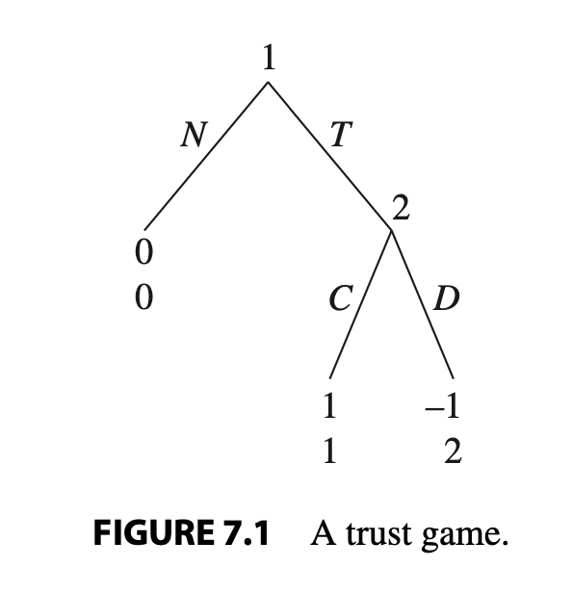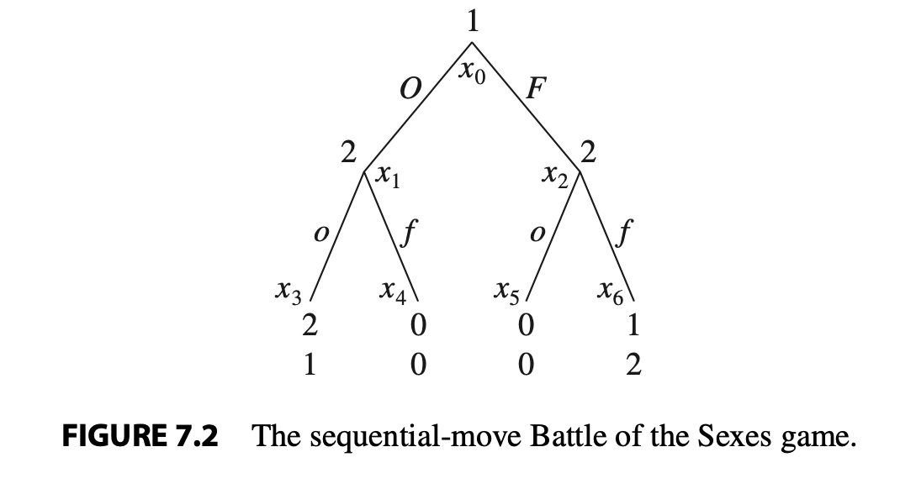
First there is Nature choosing, and then the player can make a move, the top payoff is for player 1’s payoff and the bottom number is player 2’s payoff from the specific strategy outcome.
Figure 7.2: battle of the sexes game, here we see first player 1 chooses O or F and then player 2 chooses o or f to get the payoffs.

Game tree: a set of nodes, transitive, asymmetric, incomplete
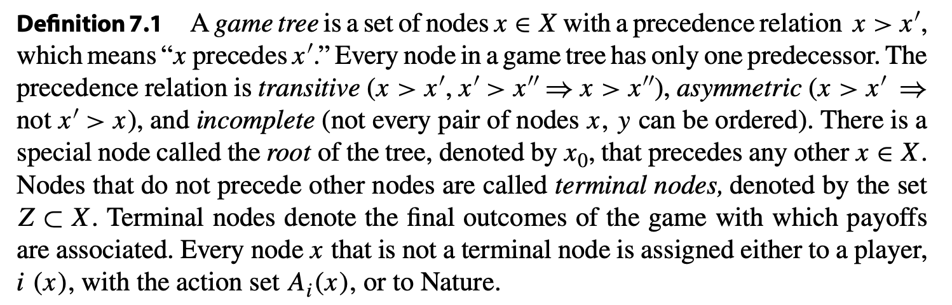
Root: the node $x_{0}$ that precedes all others.
Terminal nodes: nodes that do not precede other notes, so we terminate here, the end notes.
The rest: either assigned to the choice of a player or nature.
A game with a dummy player:
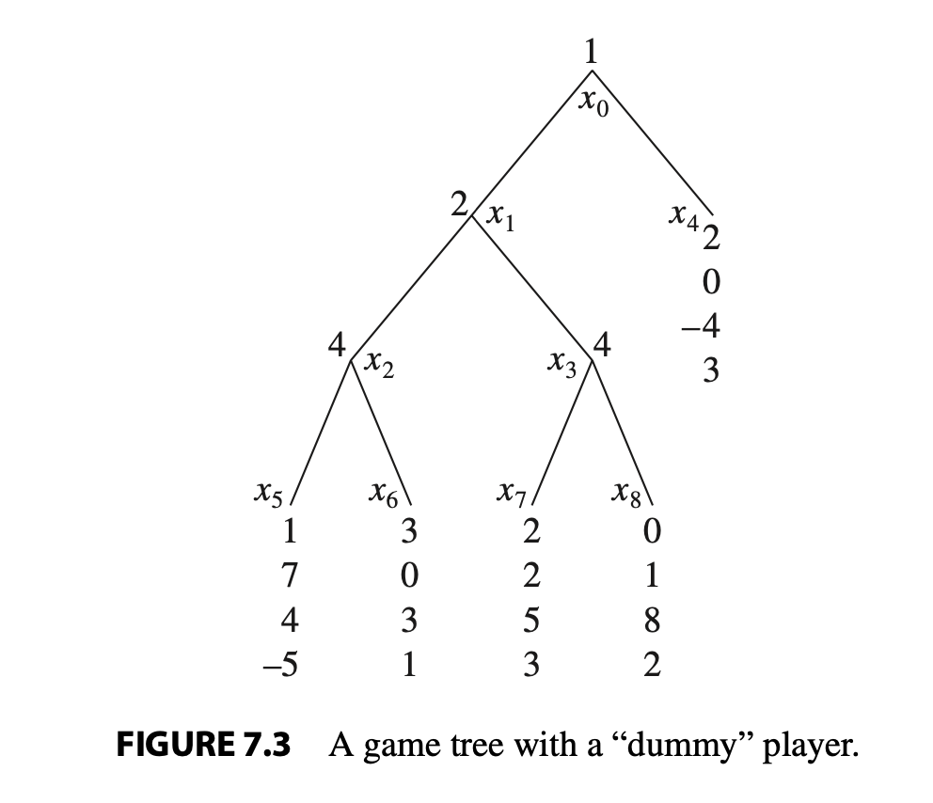
So we see that player 1 starts, maybe player 2 then goes, and if player 2 goes player 4 goes (but for two different outcomes) player 3 never goes.
How to see in a tree if the player at a certain node knows what happened before?
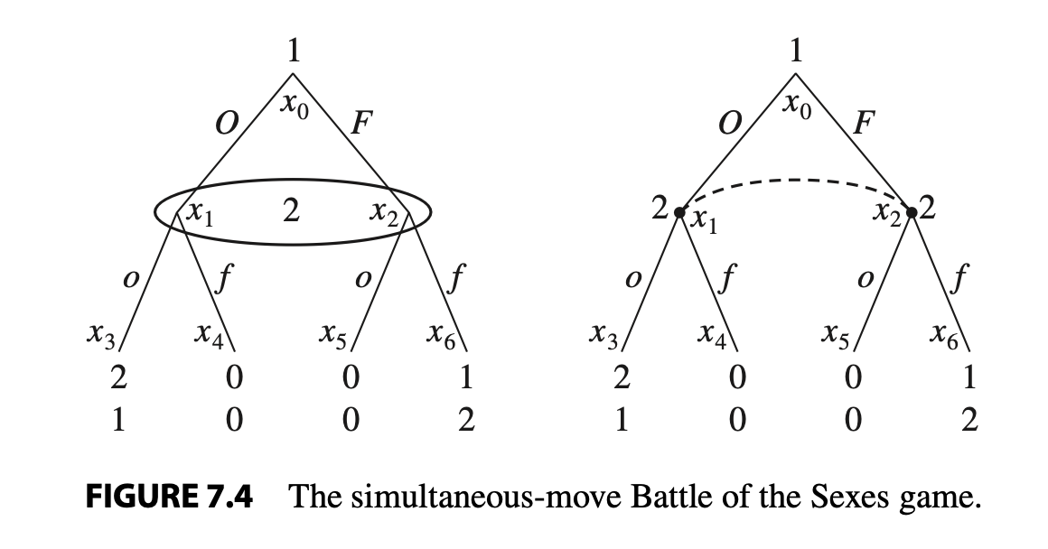
Definition of the information of player i
Every player i has a collection of information sets $h_{i}∈H_{i}$ that partition the nodes of the game at which player i moves with the following properties:
- If $h_{i}$ is a singleton that includes only x then player i who moves at x knows that he is at x.
- If $x≠x^{'}$ and if both $x∈h_{i}$ and $x^{'}∈h_{i}$ then player I who moves at x does not know whether he is a x or x’.
- If $x≠x^{'}$ and if both $x∈h_{i}$ and $x^{'}∈h_{i}$ then $A_{i}\left(x^{'}\right)=A_{i}\left(x\right)$.
This last one means that we need to actions at the different nodes to be the same if a player does not know at which note they are as otherwise they should be able to guess from the actions they can take.

Imperfect versus perfect information
A game of complete information in which every information set is a singleton and there are no moves of Nature is called a game of perfect information. A game in which some information sets contain several nodes or in which there are moves of Nature is called a game of imperfect information.
Exogenous uncertainty: when a player does not know the move of nature.
Endogenous uncertainty: when a player does not know what other players did.

Strategies and Nash equilibrium
- Pure strategies
Battle of the sexes: Player 1 has a single information set with one node, player 2 has two information sets, depending on the actions of player 1. So if player 2 knows what player 1 choose he can make a smarter decision based on the information.
Pure Strategies in Extensive-Form Games: A pure strategy for player i is a complete plan of play that describes which pure action player i will choose at each of his information sets.
Simultaneous game: there is a circle in the middle like to the right in the picture.
Sequential move game: there is no circle, so we can see they are dependent on the ones from before.
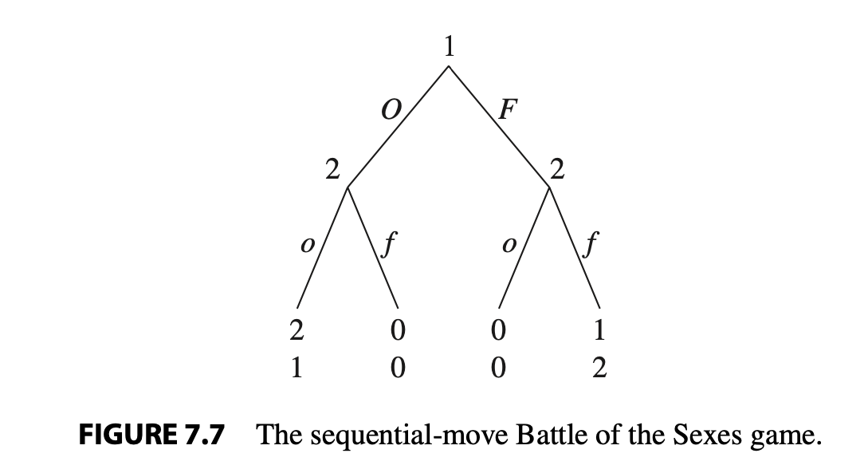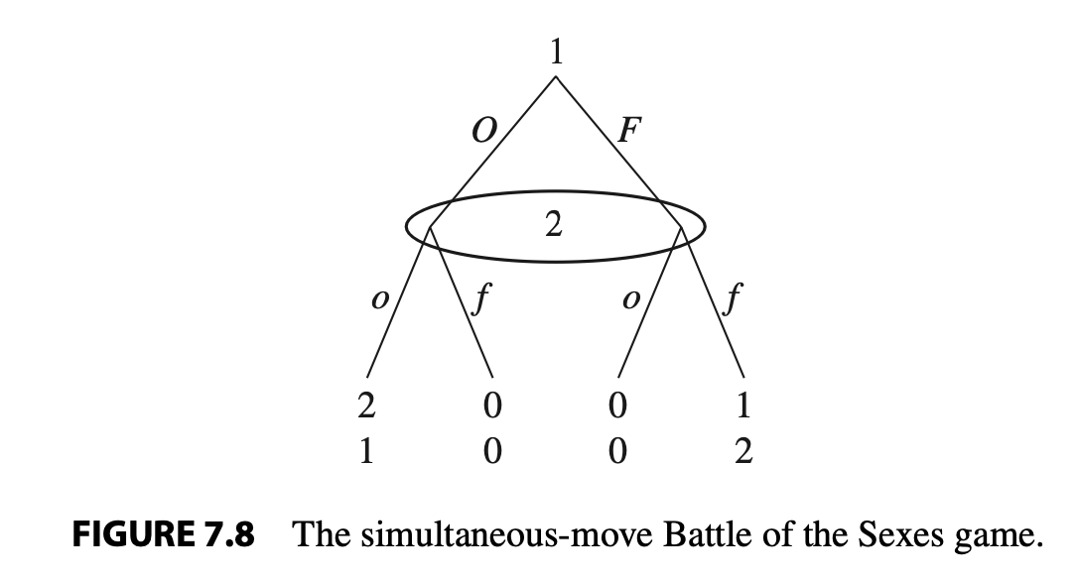

Set of pure strategies: to see the pure strategies one player can choose depending on the players before them, so it becomes like a sequence of the choices.
A pure strategy for player i is a mapping $s_{i}:H_{i}→A_{i}$ that assigns an action $s_{i}\left(h_{i}\right)∈A_{i}\left(h_{i}\right)$ for every information set $h_{i}∈H_{i}$. We denote by $S_{i}$ the set of all pure-strategy mappings $s_{i}∈S_{i}$.
Total number of pure strategies: the product of the different amount of actions in the different information sets. So for 3 information sets with 2 actions in the first, 3 in the second and 4 in the third there are 24 pure strategies.

Mixed versus behavioral strategies
A mixed strategy for player i is a probability distribution over his pure strategies $s_{i}∈S_{i}$.
A behavioral strategy: specifies for each information set $h_{i}∈H_{i}$ an independent probability distribution over $A_{i}\left(h_{i}\right)$ and is denoted by $σ_{i}:H_{i}→ΔA_{i}\left(h_{i}\right)$, where $σ_{i}\left(a_{i}\left(h_{i}\right)\right)$ is the probability that player I plays action $a_{i}\left(h_{i}\right)∈A_{i}\left(h_{i}\right)$ in information set $h_{i}$.
A game of perfect recall is one in which no player ever forgets information that he previously knew.

Normal form representation of extensive form games
Copied:
Any extensive-form game can be transformed into a normal-form game by using the set of pure strategies of the extensive form (see definition 7.4) as the set of pure strategies in the normal form, and the set of payoff functions is derived from how combinations of pure strategies result in the selection of terminal nodes. Furthermore every extensive-form game will have a unique normal form that represents it, which is not true for the reverse transformation (see the following remark).
Though every extensive form has a unique normal-form representation, it is not true that every normal form can be represented by a unique extensive-form game.

Nash Equilibrium and paths of play
Let $σ^{⋆}=\left(σ_{1}^{⋆},…,σ_{n}^{⋆}\right)$ be a Nash equilibrium profile of behavioral strategies in an extensive form game. We say that an information set is on the equilibrium path if given $σ^{⋆}$ it is reached with positive probability. We say that an information set is off the equilibrium path if given $σ^{⋆}$ it is never reached.

Credibility and sequential rationality (chapter 8)
What is rational behavior.
Rational players play optimally in response to their beliefs whenever they are called to move.

Sequential rationality and backward induction
A player uses strategy that is optimal at every information set in the game tree.
Sequentially rational: given strategies $σ_{-i}∈ΔS_{-i}$ of I’s opponents, we say that $σ_{i}$ is sequentially rational if and only if I is playing a best response to $σ_{-i}$ in each of his information sets.
Backward induction game: start at the end of the sequential game and move until you have a solution.
Any finite game of perfect information has a backward induction solution that is sequentially rational. Furthermore if no two terminal nodes prescribe the same payoffs to any player then the backward induction solution is unique.
Any finite game of perfect information has at least one sequentially rational Nash equilibrium in pure strategies. Furthermore if no two terminal nodes prescribe the same payoffs to any player then the game has a unique sequentially rational Nash equilibrium.

Subgame-perfect Nash equilibrium: Concept
We expect rational players to play in ways that are sequentially rational.
Backward induction can only be applied to games of perfect information.
Cannot be applied to games that do not necessarily end in finite time. If they do not have terminal nodes where do we start?
Proper subgame: A proper subgame G of an extensive-form game $Γ$ consists of only a single node and all its successors in $Γ$ with the property that if $x∈G$ and $x'∈h(x)$ then $x'∈G$. The subgame G is itself a game tree with its information sets and payoffs inherited from $Γ$.
Subgames in a game with perfect information:
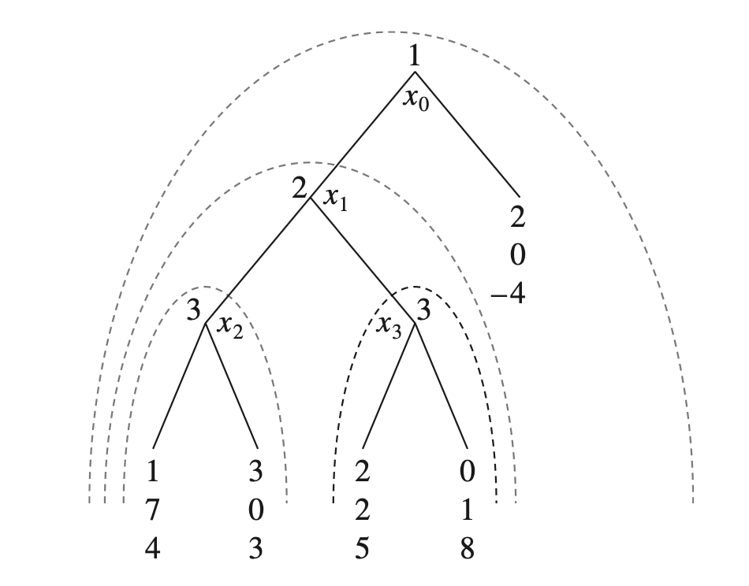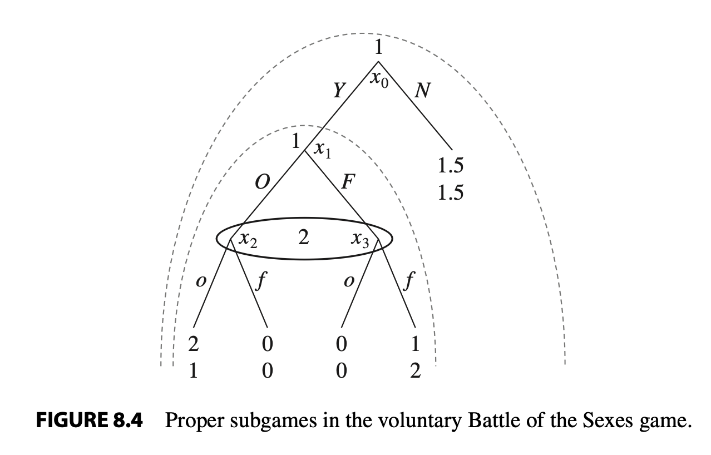
Subgames can only be subgames if they belong to different information sets.
Subgame-perfect Nash equilibrium: let $Γ$ be an n-player extensive form game. A behavioral strategy profile $σ^{⋆}=\left(σ_{1}^{⋆},σ_{2}^{⋆},…,σ_{n}^{⋆}\right)$ is a Subgame-perfect Nash equilibrium if for every proper subgame G og $Γ$ the restriction of $σ^{⋆}$ to G is a Nash equilibrium in G.
So we need it to be a Nash equilibrium for the smaller game, the subgame when we are not looking at the other factors not part of the subgame.
For any finite game of perfect information, the set of subgame-perfect Nash equilibria coincides with the set of Nash equilibria that survive backward induction.

Subgame-perfect Nash equilibrium: Examples
- The centipede game
They can each continue the game or terminate the game for different payoffs, they switch so first ones chooses to continue or terminate and then the other, for however long, in the example they choose 2 times each. So there are 5 different outcomes, they each choose to stop at their given point, or it continues the whole way through.
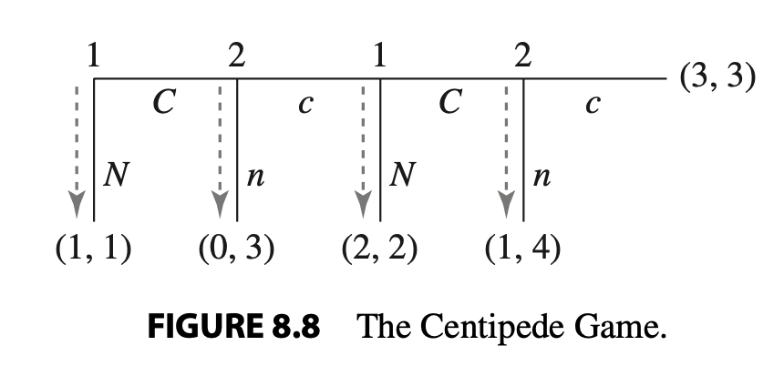
They will end up getting 1 each cause they know what the next person would choose so the first player will choose N at the start for payoff (1,1)
From class we have:
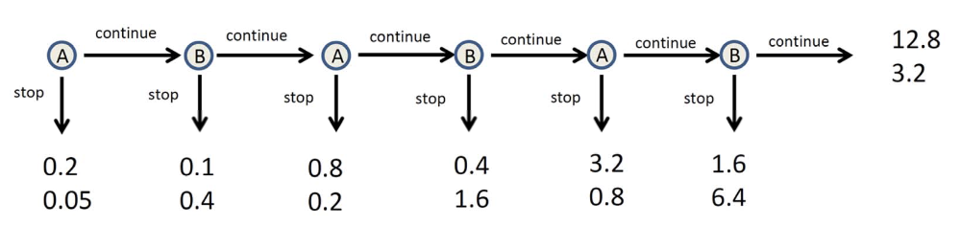
They will stop immediately.
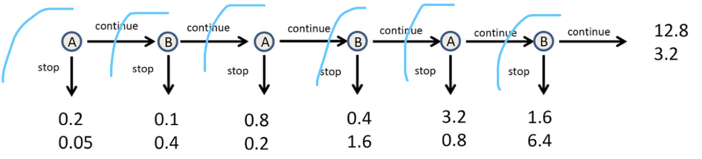
There are 6 subgames.
$$\left(sss;sss\right)=\left(stop whenever it is your turn:stop whenever it is your turn\right)$$
They will all choose to stop in the subgame where they decide.

- Stackelberg competition
When they do not choose amount simultaneously but one chooses first, this is important for the outcome.

- Mutually assured destruction
imperfect information. Cuba crisis, if you don’t back off we both pay dearly.
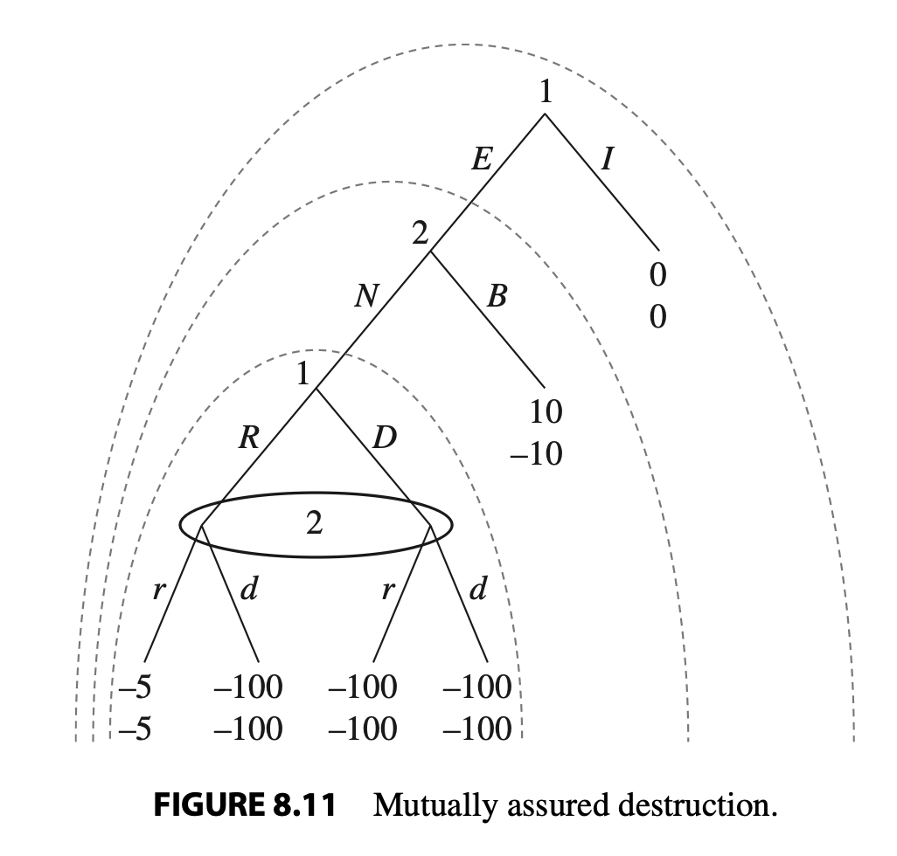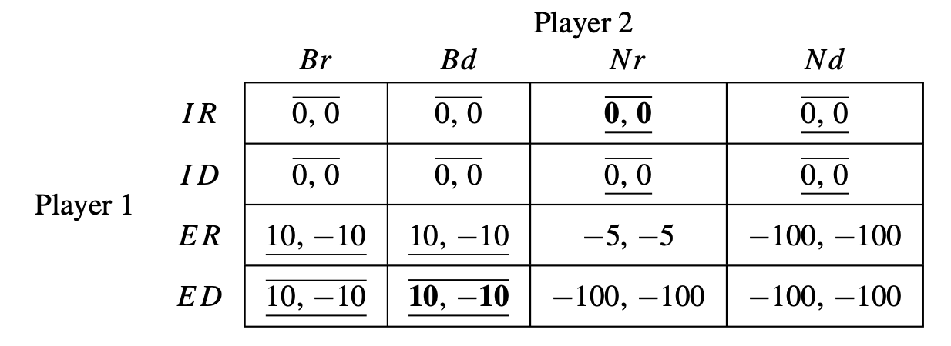
If they both choose to Nuke both loose a lot, if they both choose to retreat both loose a little as it costs to get ready for war. So they would have to stop even earlier. No one want to get to the last subgame.

- Time inconsistent preferences
Smooth consumption, take into account is it worth more or less in the future.
So if you make a plan at the start do you stick with it as time goes or do you deviate.

Dynamic games of complete information (forelæsning)
If we have
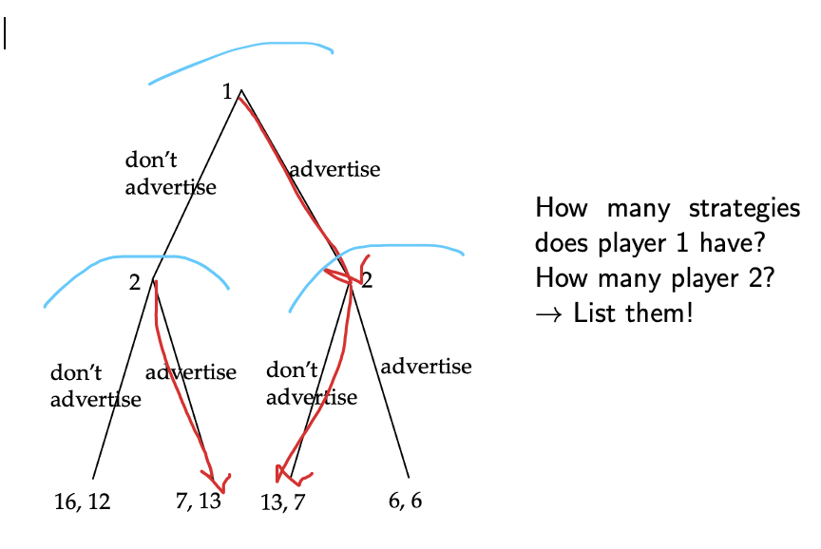
Then we see that er end up with the first person advertising and the second person not advertising.
We can also apply backward induction to
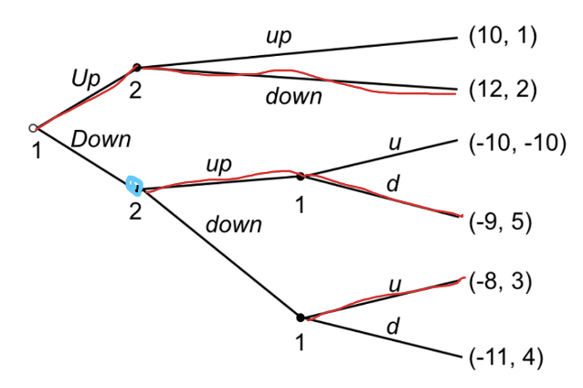
What would player 2 think if he was at the blue decision point? He would think a lack of rationality/ an error. How would we proceed if player 1 is no longer seen as rational, so we learn from the fact that player 1 did not do the smart thing?
In these type of games we will always continue as if it was an error, so continue on the same path that seems best at the new point.

- Restrictions of backward induction example:
We have the game:
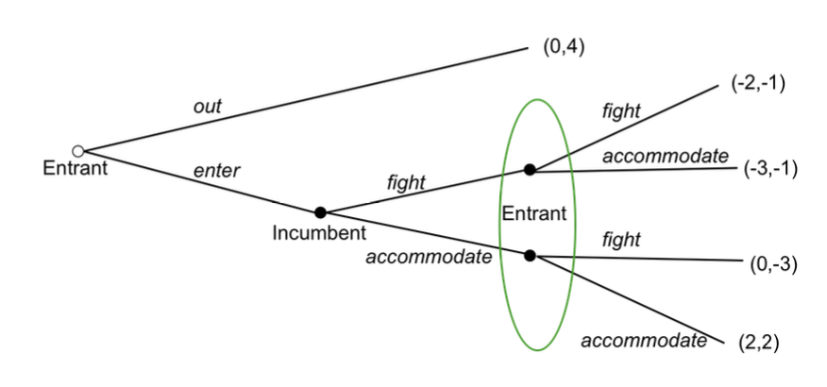
There are two subgames, the game as a whole, and the game starting at “incumbent”
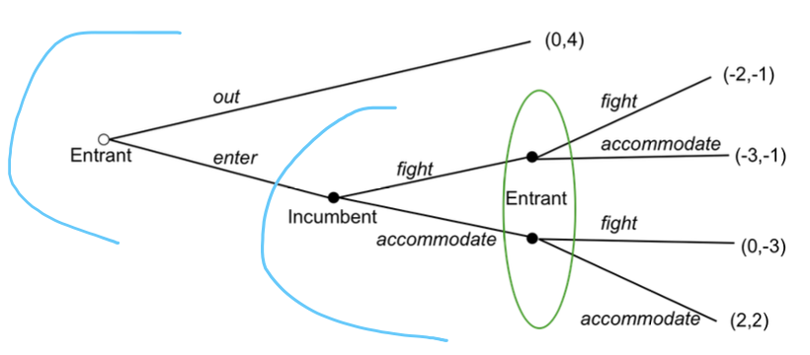
We have
E \ I | fight | accomodate
Enter, accom | -3, -1 | 2, 2
Enter, fight | -2, -1 | 0, -3
Out, accom | 0, 4 | 0, 4
Out , fight | 0, 4 | 0, 4
So we have
E \ I | fight | accomodate
Enter, accom | -3, -1 | 2, 2
Enter, fight | -2, -1 | 0, -3
Out, accom | 0, 4 | 0, 4
Out , fight | 0, 4 | 0, 4
So we have the 3 Nash equilibrium (I think there should be more yellow here but we still get the 3 NE)

Now if we look at only the subgame that starts at the incumbent.
E \ I | fight | accomodate
Fight | -2, -1 | 0, -3
accomodate | -3, -1 | 2, 2
If we look only at this subgame we see that it has two Nash equilibria
E \ I | fight | accomodate
Fight | -2, -1 | 0, -3
accomodate | -3, -1 | 2, 2
So when we have two equilibria there is usually also a mixed equilibrium.
$$NE:\left(fight;fight\right),\left(accom;accom\right),\left(\left(\frac{3}{5},\frac{2}{5}\right);\left(\frac{2}{3},\frac{1}{3}\right)\right)$$
$\left(a;a\right)$ is a NE of the subgame. Subgame perfect equilibria.
No $\left(a;f\right)$ is not a NE of the subgame.
$\left(f;f\right)$ is a subgame perfect equilibria.

Bargaining

Dictator game
Two players split a pie of size 1. Player 1 proposes $\left(s,1-s\right)$. What is the Nash equilibrium?
So this is a pretty boring equilibrium as it is a dictator and so he can just keep everything to himself, if this reflects the payoffs, he can just maximize his own payoff.

Ultimatum game
Player 1 can make a take-it-or-leave it offer to 2. So implement the offer from 1 or reject and they both get 0.
So again player 1 keeps the whole pie for themselves.
If we are only working in extremes we get
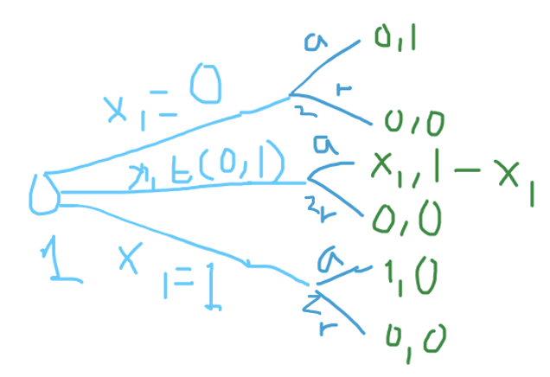
If we apply backwards induction we get
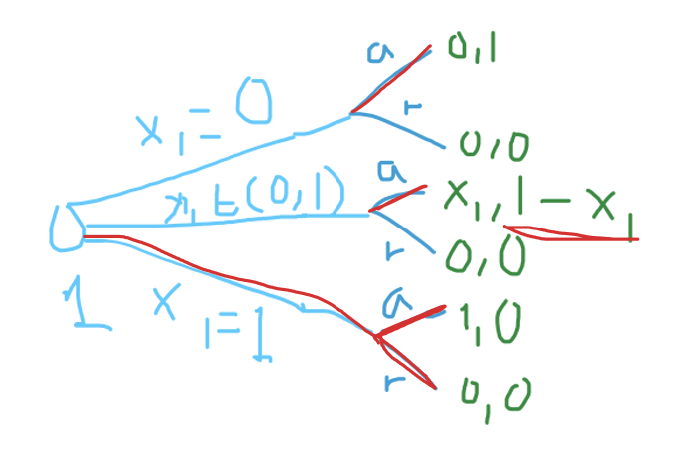
The pie is infinitely divisible. Technicality of infinitely divisible pie.
We know player 2 will always accept when player 1 plays less than or equal to x, so best response of player 1 is then to claim exactly x.

- Inequity-aversion (Fehr-Schmidt utility function
A players utility depends on own payoff and other player’s payoff
$$Own payoff$$
$$-α·\max\left\{others payoff-own payoff, 0\right\}$$
$$-b·\max\left\{own payoff-others payoff, 0\right\}$$
So your own payoff minus some assumptions about hwo one does not want inequality, we have $β≤α$ as one would rather have inequality where one is better off than the other, not the other way around. And $0≤β≤1$.

- Intention based reciprocity
Players care about the intentions that players have.
This is a type of social preference.

Bargaining with counter-offer
We have the game tree, with $δ∈\left(0,1\right)$ so
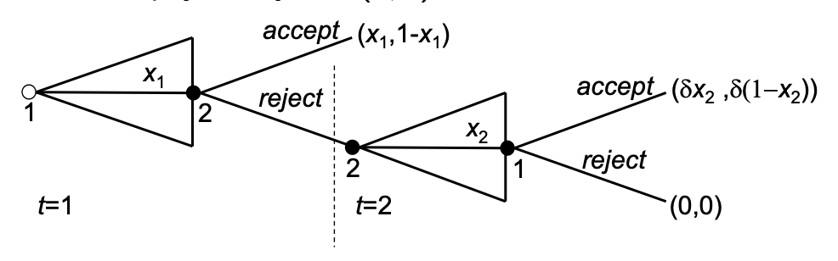
Use backwards induction, $δ=\frac{1}{1+r}$. Discount factor, a characteristic of our players, can be seen as a measure of your personal impatience, if the payoff arrives in one year some people might see it as quite worthless.
In subgame $t=2$ it has the unique outcome $\left(δ·0, δ·1\right)$ so player 2 can get the whole pie. So in game 1 player 1 has to offer $1-x_{1}$ to player 2 $≥δ$ for player 2 to accept this offer. So the equilibrium offer is then $\left(1-δ,δ\right)$.
So we can see it is good for player 2 to be patient, have a higher discount factor $δ$ as the higher it is the higher they will get, the higher player 1 will have to offer at time 2.

Finite horizon bargaining
It is an ultimatum game
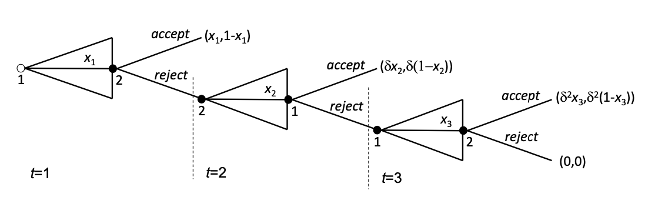
Because player 1 will at time 3 try to get the whole pie we have, $x_{3}^{⋆}=1⇒u_{1}^{⋆}=δ^{2}$.
At time t=2 we have for player 1 to accept the offer need $δx_{2}≥δ^{2}⇒x_{2}^{⋆}=δ⇒u_{2}^{⋆}=δ\left(1-δ\right)$.
So at time t=2 player 2 should suggest $x_{2}^{⋆}=δ$ to get player 1 to accept.
At time t=1 for player 2 to accept we then need $1-x_{1}≥δ\left(1-δ\right)=δ-δ^{2}⇒x_{1}^{⋆}=1-δ+δ^{2}$.

Different periods: the offer player 1 should make at the start depending on how many periods there are total in the game
For one period we have $x_{1}^{⋆}=1$
For two periods we have $x_{1}^{⋆}=1-δ$
For three periods we have $x_{1}^{⋆}=1-δ+δ^{2}$
For four periods we have $x_{1}^{⋆}=1-δ+δ^{2}-δ^{3}$
So we see the way it works here, and we can continue like this for however many periods we would like.
This is called alternating offers bargaining. Remember $δ∈\left(0,1\right)$.
If the first person does not make this specific order and we go to the next period then player 2 should offer
For two periods we have $x_{2}^{⋆}=δ$
For three periods we have $x_{2}^{⋆}=δ-δ^{2}$
For four periods we have $x_{2}^{⋆}=δ-δ^{2}+δ^{3}$
So we see it is the opposite fortegn(we are now an even numbered period and it is opposite)
Generally speaking we have from slides
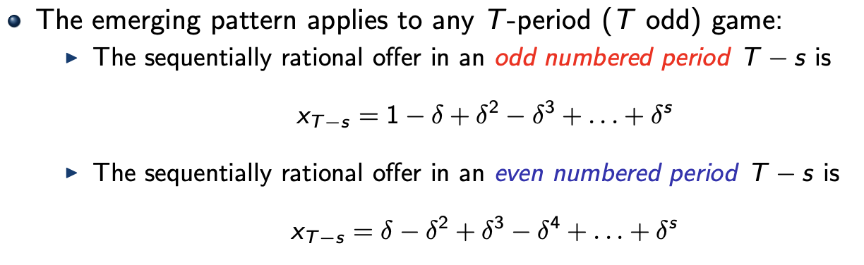
Subgame perfect equilibrium:
$$SPE=\left(\left(propose x_{T-s} in period T-s, accept any offer≥x_{T-s}^{even} reject otherwise\right);\left(propose x_{T-s} in even period T-s, accept any offer≥x_{T-s}^{odd} reject otherwise\right)\right)$$

In this game both the proposals of both player is the amount kept by player 1, so when player 2 proposes an offer the offer is how much goes to player 1.
Player 1’s offer in the first period should be
$$x_{1}^{⋆}=\frac{1-δ^{T}}{1+δ}$$
Where T is odd(what about when T is even?)
Then we have the payoffs
$$u_{1}^{⋆}=x_{1}^{⋆}=\frac{1-δ^{T}}{1+δ}, u_{2}^{⋆}=1-x_{1}^{⋆}=\frac{δ-δ^{T}}{1+δ}$$

Alternating offer game (Rubinstein game) goes on forever, infinite
So here we have
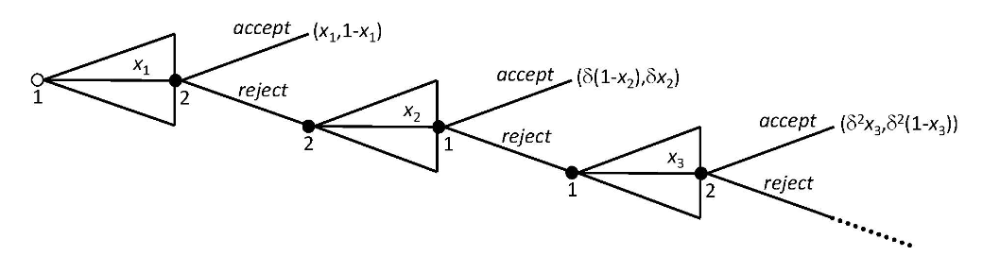
Now we have that both players choose the amount they would like to keep for themselves, so not just saying what player 1 should have, but say what they want to have themselves.
We cannot do backwards induction because there is no end, it is infinite.
There is a stationary structure, we assume the players apply a stationary strategy.

Stationary strategy: players always make the same proposal whenever they are in a situation to propose, and they always make the same decision whether to accept or reject. Players do not get angry or something even if there have been 20 periods they keep the same strategy for when they accept or reject.

We call these stationary strategies for $x_{1}^{⋆}$ and $x_{2}^{⋆}$ so the only thing that really matters is when your proposal goes through, the later it is the lower the payoff as we still have the discount factor $δ$.
It is a perfect information game.
A player will accept the offer if it is at least the same amount as the proposal they would have made themselves. Assume no delay.
No delay: equilibrium proposal will be accepted.
Taking player 2’s perspective: accept if $1-x_{1}≥δ·x_{2}^{⋆}$ so we need to also take the depreciation into account.
$$⇒x_{1}=1-δ·x_{2}^{⋆}$$
This comes from them wanting to keep as much as possible for themselves, so this is the minimum needed for player 2 to accept the offer.
From player 1’s perspective: accept $1-x_{2}≥δx_{1}^{⋆}⇔x_{2}=1-δx_{1}^{⋆}$.
Now we have two equations with two unknowns and we get
$$x_{1}=1-δ\left(1-δ·x_{1}^{⋆}\right)$$
$$x_{1}^{⋆}=\frac{1-δ}{1-δ^{2}}=\frac{1}{1+δ}$$
So this is the equilibrium strategy for player 1.
The payoff is then
$$u_{1}=\frac{1}{1+δ}, u_{2}=\frac{δ}{1+δ}$$
There is first mover advantage, being patient in bargaining is better.
Generally for different depreciation we get
$$u_{1}^{⋆}=\frac{1-δ_{2}}{1-δ_{1}·δ_{2}}, u_{2}^{⋆}=\frac{δ_{2}\left(1-δ_{1}\right)}{1-δ_{1}·δ_{2}}$$

- One deviation principle
$s^{⋆}$ is a SPE if no player I has a strategy $\tilde{s_{i}}$ differing from $s_{i}^{⋆}$ in just one information set $H∈H_{i}$ and doing strictly better than $s_{i}^{⋆ }$ conditional on H being reached.
One stage deviation principle.

Example:
If we have a game with only 1 player like this.
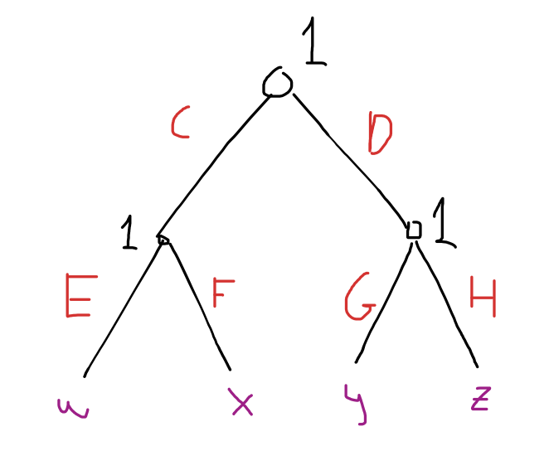
And the strategy CEG satisfies one-deviation principle it means he does not get more payoff if he deviates in a single node, this means we know $w>x$ and $y>z$. So we must also know that $w>y$. If I cannot deviate in a single note, then I cannot either do better if I switch to a strategy that is different in more than one note.
So for example DEH or DFG. So they differ in two nodes, then we know these two cannot be better strategies.

Repeated games slides
Players face the same stage game in each of multiple periods.
Stage game: a matrix
Given a stage game G denote the finitely repeated game in which G is played T times by $Γ^{T}$. Where $T∈N$.

Example of twice repeated prisoners dilemma with stage game
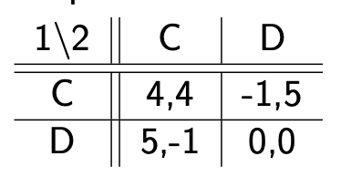
So for player 1 we have the possibilities
$$2^{5}=32$$
Different strategies.
And the same for player 2. But we could narrow it down by looking at what they already know, and then what would be smart to do, we get the ones they would actually play.
Given that $\left(D;D\right)$ is the unique Nash equilibrium in the prisoners dilemma the only thing that can happen in this repeated game is at the last stage they choose to deviate. So the second period payoffs will be 0.
If the game is repeated a finite number of time there is no way out, always back to the Nash equilibrium, $\left(D;D\right)$ is subgame perfect equilibrium.

If the stage game $Γ$ has a unique NE $s^{⋆}$, then T-fold play of $s^{⋆}$ independently of the current history is $Γ^{T}$’s unique SPE.
If $s^{⋆}$ is a NE of the stage game $Γ$, then T-fold play of $s^{⋆}$ independently of the current history is a SPE of $Γ^{T}$.

- Finitely repeated games
If we have multiple equilibria in a matrix more interesting things can happen even though it is finitely repeated.
For 2-fold play of
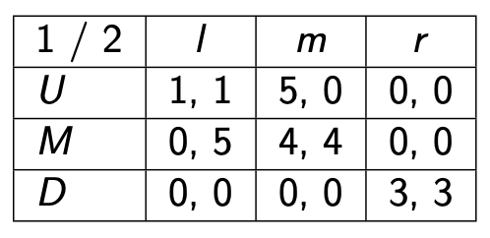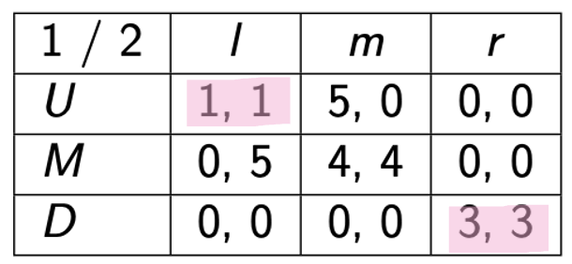
So here we get $\left|s_{i}\right|=3^{10}=59049$ different strategy sets.
We know in the last stage there has to be a Nash equilibrium, for there to be subgame perfect equilibrium.
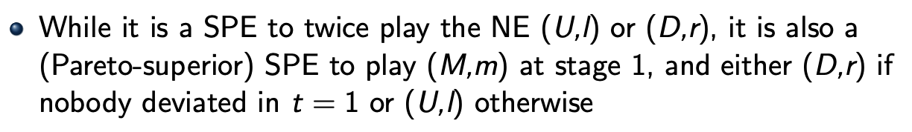
If they stick to the plan then they both get 7, if they deviate given that the other person sticks to the plan

- Re-negotiation proofness
Twice repeated game:
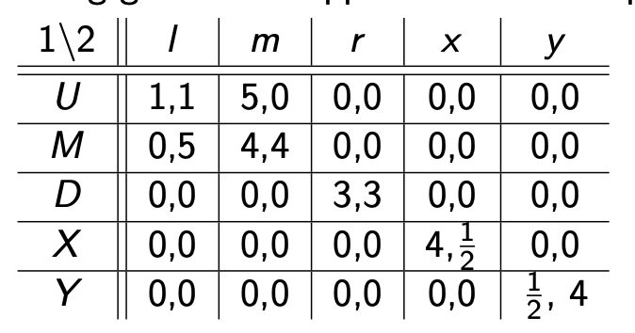
I think they are two, maybe 1?
$$\left(U;l\right),\left(D;r\right) \left(X;x\right),\left(Y;y\right)$$
Good for punishment in the case that player 3 messes up the $\left(M;m\right)$ in the first stage.

Infinitely repeated games
Given a stage game G let $Γ^{∞}$ denote the infinite repetition of exactly the same finite normal form game G where players try to maximize their discounted sum of payoffs (with common discount factor $δ∈(0,1)$).
Player I’s discounted sum of payoffs, so the present value of the payoffs is
$$\sum_{t=1}^{∞}{δ^{t-1}u_{i}\left(s_{i}^{t},s_{-i}^{t}\right)}$$
Interpretation of $δ$
- Discount factor
  - $δ=\frac{1}{1+r}$ where r is the interest rate
  - Tells us how patient a player is
- Probabilistic end of a game
  - Exogenous probability that there is a next period in a setting without discounting, this refers to indefinitely repeated games.
For $δ∈\left(0,1\right)$ we have
$$\sum_{t=1}^{∞}{δ^{t-1}}=\frac{1}{1-δ}$$
Players average payoff:
$$\left(1-δ\right)·\sum_{t=1}^{∞}{δ^{t-1}u_{i}\left(s_{i}^{t},s_{-i}^{t}\right)}$$

Example: for a finite number of time we earn a each period so
$$a+δa+δ^{2}a…=\frac{a\left(1-δ^{t+1}\right)}{1-δ}$$

Infinitely repeated prisoner’s dilemma
We again have
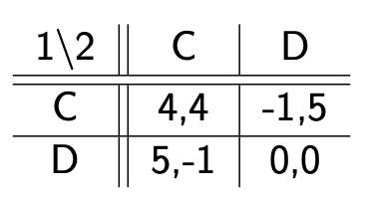
We can make it so they always choose to cooperate, which strategies make this possible? If they value the future highly enough then we can implement cooperate behavior as the subgame perfect equilibrium.
One strategy could be: play C until the other person plays D and then play D.
This strategy is called: grim trigger 0, so we play the positive one until something triggers us not to.
Tit for tat, tft, Play C until the other plays D, and then play D once, so play what your opponent played in the last game.
Is $\left(GT-0,GT-0\right)$ a NE? where GT-0 is grim trigger 0 plan.
Stick to $GT-0$ yields $\frac{4}{1-δ}$ as payoff.
Deviate yields 5, because we get 5 the first time we deviate and then 0.
Stick to the plan is better as long as $\frac{4}{1-δ}>5⇒δ>0,2$. Then it is an NE.
One deviation principle: is it worth deviating after Ø-history(no history I think) or $\left(C,C\right)$-history. So we need to look at all history not just on the equilibrium path.
Is it worth deviating after eg. $\left(C,D\right)$ history? So it is off the equilibrium path.

What do we get after $\left(C,D\right)$-history as stick to GT-0 as player 2.
Then it becomes $\left(D,C\right),\left(D,D\right),\left(D,D\right),\left(D,D\right),…$ so they have both been “triggered”.
So player 2 gets the payoffs, -1, 0,0,0,… after the $\left(C,D\right)$-history.
But what if they decide to deviate from the strategy? Deviating means instead of playing C as player 2 you try to save your skin and so you also play D, then we get
$$\left(D,D\right),\left(D,D\right),\left(D,D\right),\left(D,D\right),…$$
And the payoffs are 0,0,0,0,… so it is better to deviate, players do not want to stick to grim trigger 0 if something like the $\left(C,D\right)$-history has happened, so grim trigger 0 is not subgame perfect.
$$\left(GT-1,GT-1\right)$$
Is subgame NE for $δ=0,2$.
Maybe also SPNE?

Is Tit for Tat Nash equilibrum? $\left(TFT;TFT\right)$
 | C | D
C | 5,5 | 0,6
D | 6,0 | 1,1
If we stick to C both of us forever we get the payoff
$$5+δ·5+δ^{2}·5+…=\frac{5}{1-δ}$$
So if you deviate in 1 round you end up with the payoff from that round
$$6+δ·0+δ^{2}·6+δ^{3}·0+…=\frac{6}{1-δ^{2}}$$
For all the rounds, it switches.
So is it worthwhile or not?
So we work with average payoffs instead:
$$\left(1-δ\right)·\frac{5}{1-δ}=5$$
Then she says we also get:
$$\left(1-δ\right)·\frac{6}{1-δ^{2}}=\frac{6}{1+δ}$$
When is
$$5>\frac{6}{1+δ}$$
$⇕$ Uligheden løses for delta vha. WordMat.
$$δ<-1 ∨ δ>0,2$$
$δ≥0,2$ so for this we have that stick is better than to deviate.

Is $\left(TFT;TFT\right)$a SPE, and for which $δ$? Tit for tat
- Consider history ending in $\left(C,D\right)$:
Stick to TFT: then we get the plays $\left(D,C\right), \left(C,D\right),\left(D,C\right),\left(C,D\right)…$ then we go into infinite alternation. So we get the average payoff of $\frac{6}{1+δ}$. But what if we instead deviate from tit for tat?
So if we abstain from playing D and continue playing C. then we go back to playing $\left(C,C\right)$ forever. So we get the average payoff of 5 again. So if
$$\frac{6}{1+δ}≥5$$
$⇕$ Uligheden løses for delta vha. WordMat.
$$δ≥-1 ∧ δ≤0,2$$
Then we should stick with tit for tat if $δ<0,2$.
So we have that tit for tat can only be a subgame perfect equilibrium if $δ=0,2$ but we still have subgames to check, so might still not be?. Not a very robust subgame perfect equilibrium.

- Now consider history ending in $\left(D,C\right)$ :
Then the next play is $\left(C,D\right),\left(D,C\right), \left(C,D\right),\left(D,C\right)$ alternating like before, here the payoffs are
$$0+δ·6+δ^{2}·0+δ^{3}·6+…=\frac{δ·6}{1+δ}$$
So this is the payoff if we stick with tit for tat.
If we deviate we play $\left(D,D\right)$ and so we will continue playing $\left(D,D\right)$ forever. So the average payoff is
$$\left(1-δ\right)·\frac{1}{1-δ}=1$$
So we stick with the tit for tat if
$$δ·6≥1+δ$$
$⇕$ Uligheden løses for delta vha. WordMat.
$$δ≥0,2$$
So it is best to stick with tit for tat as long as $δ≥0,2$. We look at
$$\frac{δ·6}{1+δ}≥1⇔6·δ≥1+δ$$
So we just rewrote it.

- And consider history ending in $\left(D,D\right)$:
If we stick with tit for tat then we play $\left(D,D\right)$ forever, so we have average payoff of 1.
If we deviate we play $\left(C,D\right),\left(D,C\right), \left(C,D\right),\left(D,C\right)$ and so the payoff is again $\frac{δ·6}{1+δ}$.
So when
$$1+δ≥δ·6$$
$⇕$ Uligheden løses for delta vha. WordMat.
$$δ≤0,2$$
So again we see to satisfy both inequalities we need $δ=0,2$ for it to be subgame perfect.

- The Axelrod contest (about tit for tat)
Write a computer program with a strategy, many different strategies enteres
Grim-trigger 1
Tit for tat
Pavlov (win - stay, loose - shift) so if you won with your strategy from last round you stick to it, if you loose you shift strategy.
Also some chose random
Which strategy has in the end earned the most?
In the original contest tit for tat was the most successful. So in each round you were matched with a player playing one of these different strategies.

- On an off the equilibrium path
On the equilibrium path: stay on the path where they are always choosing the best response never a mistake. Sufficient for Nash equilibrium NE
Off the equilibrium path: what are the best course of actions now given a mistake was made, we are not where we should be but still need to look at what is best to do. Look at the history of why we are at that new specific point. Need to check for SPE. SPNE.

Folk theorems
So if you have a price that suddenly falls and then goes back up maybe a couple months later it could mean that for a period t someone had to punish the other, and then the punishment is over they cooperate again on the high prices, so everyone sets high. Prices, if someone does not follow this strategy then the others lower their prices for some time, and then everyone raises them again. Here we have that the critical delta is higher than with grim trigger for the same game.
Limited punishment strategy: could indicate the firms have some collusive k-period punishment at stake.
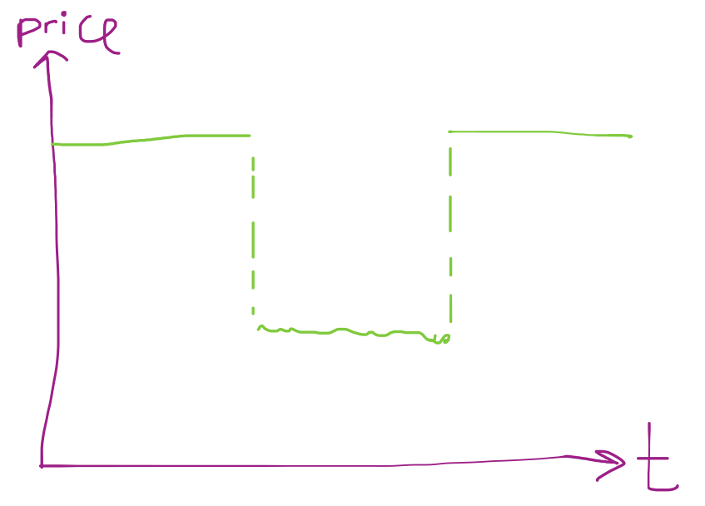
Which payoffs can be supported in an Nash/subgame perfect equilibrium of an infinitely repeated game?
A payoff vector $v=\left(v_{1},…,v_{n}\right)$ is called feasible if and only if there is a joint probability distribution $π$ in S with expected payoffs $E_{π}u\left(s\right)=v$ so if v is is the convex hull of all $u\left(s\right)$.
A payoff vector $v=\left(v_{1},…,v_{n}\right)$ is feasible in the stage game G if it is a convex combination of the pure strategy payoffs of G.
For example in the prisoners dilemma the feasible payoffs

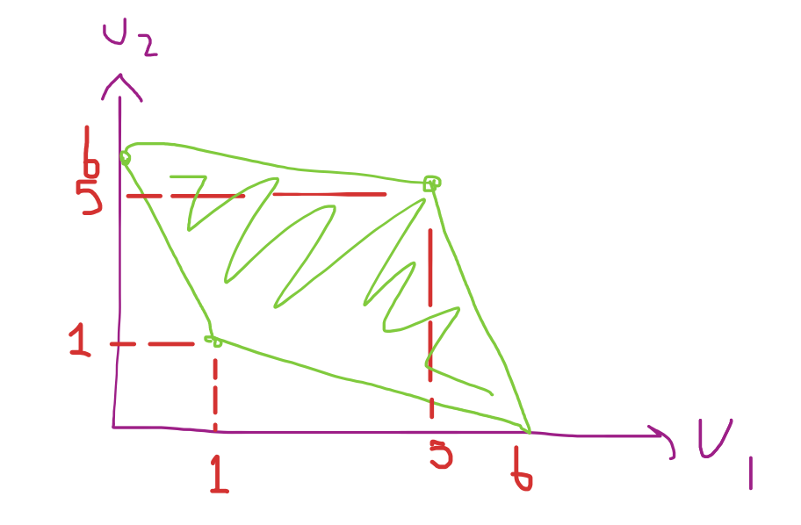
What can actually be a Nash equilibrium in an infinitely repeated game?
Everything in the green area can be implemented as a subgame perfect Nash equilibrium. Only $\left(1,1\right)$ is stage game Nash equilibrium.

Friedman’s theorem
Suppose $s^{⋆}$ is a NE of the stage game $Γ$ with payoff $u^{⋆}$. Let $v>u^{⋆}$ be feasible. Then, for $δ$ sufficiently close to 1, there exists a SPE of $Γ^{∞}$ with average payoff $≅v$.
Where average payoff is $\left(1-δ\right)·\sum_{t=0,1,…}{δ^{t}·u^{t}}$.

Illustrate feasible payoff for battle of the sexes:
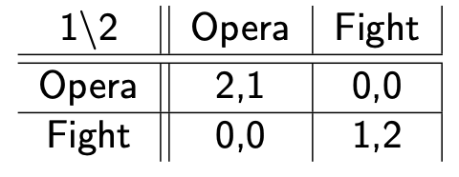
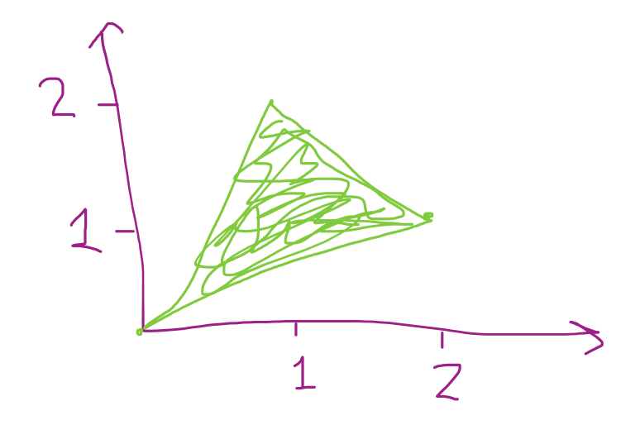
It has the equilibria $\left(opera;opera\right), \left(fight,fight\right)$ and the mixed $\left(\left(\frac{2}{3},\frac{1}{3}\right);\left(\frac{1}{3},\frac{2}{3}\right)\right)$
So we get that the red part starting from $\left(\frac{2}{3},\frac{2}{3}\right)$ is the implementable as SPE outcome.
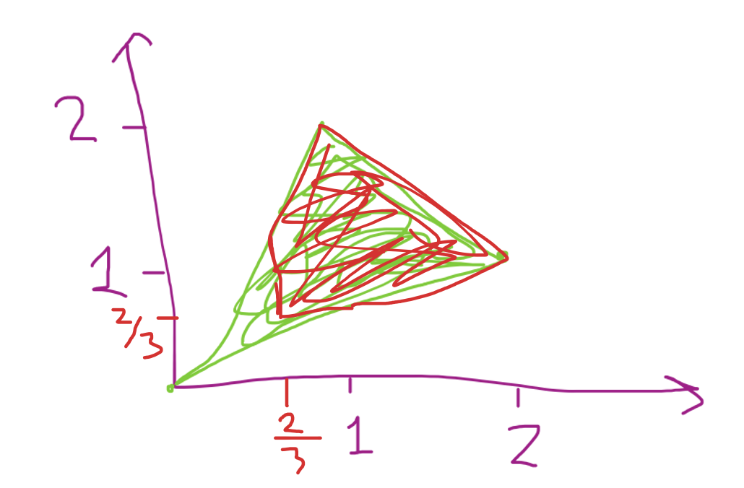
How to give a payoff $1,2<u_{1}<1,3$ how do we use a strategy to get this?
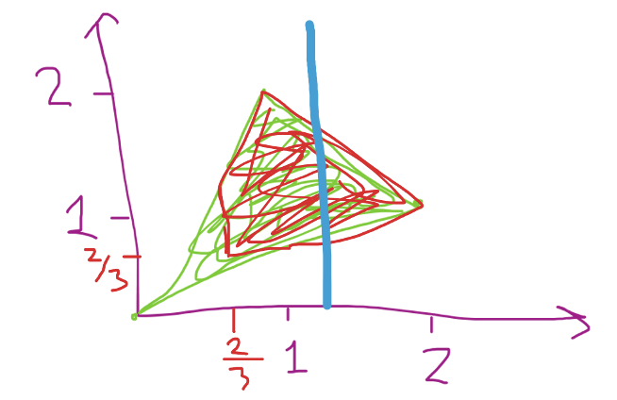
We can do this with a specific grim trigger strategy, so for example they play D or C (for the prisoners dilemma) depending on the day, so they always shift, if one does not stay they go into grom punishment phase is then to play D forever.
So we formula a grim strategy that is not as much focused on implementation forever but also do something specifically like alternating in a specific way to get the payoff we would like.
To get $1,2<u_{1}<1,3$ we can do the alternating strategy, we look at $1,25=\frac{4}{5}$ so it is in the middle and so as $\left(opera;opera\right)$ gives player 1 a payoff of 2, and $\left(fight;fight\right)$ gives a payoff of 1, so we can say
$$1,2<\frac{a·2+b·1}{a+b}<1,3$$
So what could they be? We could have $a=1,b=3$ so we get
$$\frac{1·2+3·1}{1+3}=1,25$$
Like we wanted. So the rhythm is we play 1 time $\left(opera;opera\right)$ and 3 times $\left(fight;fight\right)$. This written down is then the cycle is
$$\left(o;o\right),\left(f;f\right),\left(f;f\right),\left(f;f\right)$$
So the strategy for both players is
Play o in period 1,5,9.. and play f in the others. So in 5*k-1 periods we play o, and we play f in the rest. If someone has deviated in this cycle we grom trigger and then play D(what is that in this example?)
A lot is possible in these repeated games as long as our players are patient enough.
The Friedman theorem tells us that anything in the red area is a possible SPNE.
In these types of game theories almost anything goes.

Static games of incomplete information
For example a person might have to decide whether or not to enter a market not knowing the costs in the market, so not knowing the different ways the incumbent might be making their decision, the entrant does not know which game they are playing, so he does not know what the best course of action for the incumbent is as the incumbent has different payoffs depending on the type of the game, size of the cost.

- Harsanyi’s transformation
Introduce a move by nature, so nature decides which game it is, and the entrant does not, so nature chooses low cost with probability p and high cost with probability 1-p and the entrant does not know which one is chosen when they have to make their choice.

- Example 1
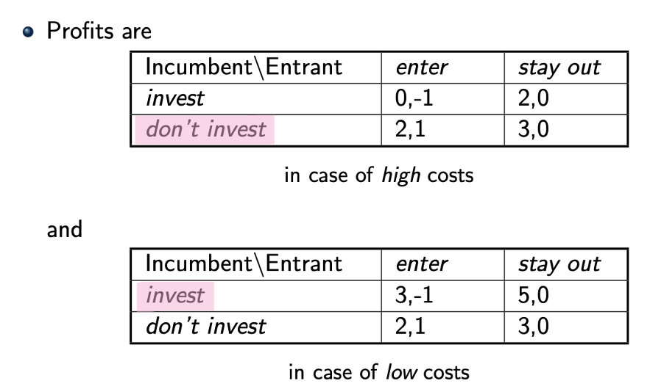
We see that the incumbent will choose don’t invest for high costs, and invest for low costs. And we see with the payoffs for the entrant we see if the probability of high costs is $p>0,5$ he will choose to enter, and if $p<0,5$(so there is larger probability of low costs) he will chose to stay out.
$$u_{E}\left(enter\right)=p·1+\left(1-p\right)·\left(-1\right)=2·p-1$$
We see here it switches at $p=0,5$ as he gets payoff of 0 for stay out no matter what, and either -1 or 1 for enter depending on what the incumbent chooses.
So we get
$$\begin{aligned}\left(Dont invest;enter\right) if p≥\frac{1}{2} \\ \left(invest;stay out\right)if p≤\frac{1}{2}\end{aligned}$$
So this is the strategy. So it is dependent on p.

- Example 2
High costs
I \ E | enter | Stay out
Invest I | 0, -1 | 2, 0
Don’t invest D | 2, 1 | 3, 0

Low costs
I \ E | enter | Stay out
Invest I | 1.5 , -1 | 3.5 , 0
Don’t invest D | 2, 1 | 3, 0
We have that p is the probability of high costs.

The game tree is
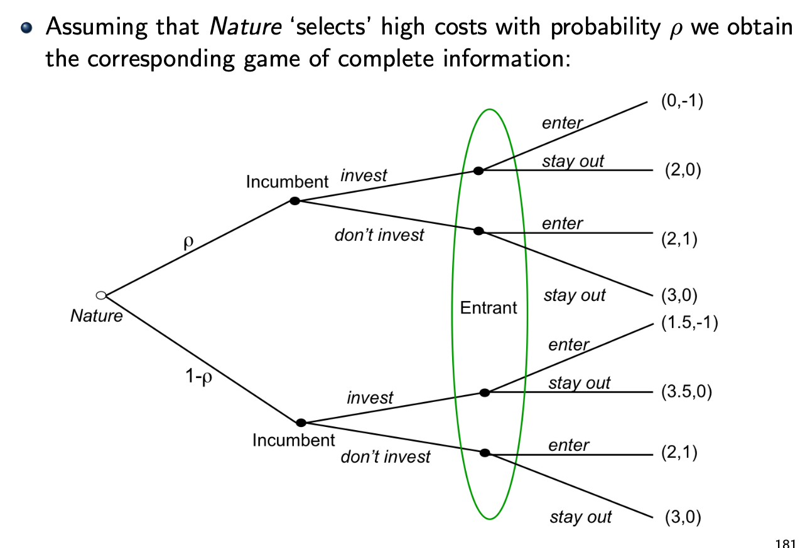
The possible strategies for the incumbent are $II, DD, ID, DI$ where $DI$ is the one we found above, don’t invest if high cost, invest if low cost. The entrant just has enter or stay out, not depending on anything as he does not know any more

Incumbent \ Entrant | Enter | Stay out
II
DD
ID
DI

What can we say?
- $I_{n}$ will always choose D
- Let q deonte the probability the incumbent assigns to entry, so we have $〈q〉$ and $〈1-q〉$

$$u_{IE}\left(invest\right)=q·1,5+\left(1-q\right)·3,5=3,5-2·q$$
$$u_{IE}\left(don^{'}t invest\right)=q·2+\left(1-q\right)·3=3-q$$
We are looking at
I \ E | Enter $〈q〉$ | Stay out $〈1-q〉$
Invest I $〈p〉$ | 1.5 , -1 | 3.5 , 0
Don’t invest D $〈1-p〉$ | 2, 1 | 3, 0
So we can make a best response to this. For the incumbent
$$3,5-2·q>3-q⇒0,5>q$$
$$BR_{IE}\left(\left(q,1-q\right)\right)=p\left(q\right)=\left\{\begin{aligned}invest if q<\frac{1}{2} \\ \left[0,1\right], if q=\frac{1}{2} \left(he is indifferent\right) \\ dont invest if q>\frac{1}{2}\end{aligned}\right.$$
I think this is it, check slides she did not make it completely clear.
For the entrant we have the best response from
$$u_{E}\left(enter | p\right)≥u_{E}\left(stay out | p\right)$$
$$ρ·1+\left(1-ρ\right)·\left[p\left(-1\right)+\left(1-p\right)·1\right]≥0$$
Enter if
$$p≤\frac{1}{2\left(1-ρ\right)}$$
Where $ρ$ is the probability from nature choosing the one with high cost. (I just called this p higher up but it is rho so not to be confused…)
$$BR_{E}\left(p,1-p\right)=\left\{\begin{aligned}enter, if p<\frac{1}{2\left(1-ρ\right)} \\ \left[\right], if p=\frac{1}{2\left(1-ρ\right)} (indifferent) \\ stay out, if p>\frac{1}{2\left(1-ρ\right)}\end{aligned}\right.$$
So if $ρ=\frac{1}{2}⇒\frac{1}{2\left(1-ρ\right)}=1$ and so we always enter
If $ρ>\frac{1}{2}⇒$ something I cannot read
If $ρ<\frac{1}{2}⇒\frac{1}{2\left(1-ρ\right)}<1$.

So the Bayesian Nash equilibrium BNE
$$\left(DD;enter\right)=\left(0,0,1\right)$$
Where we have that the last one is (high cost not invest, low cost not invest, q) so there is no chance of not investing, no matter the cost, and the chance of ending up in high cost.
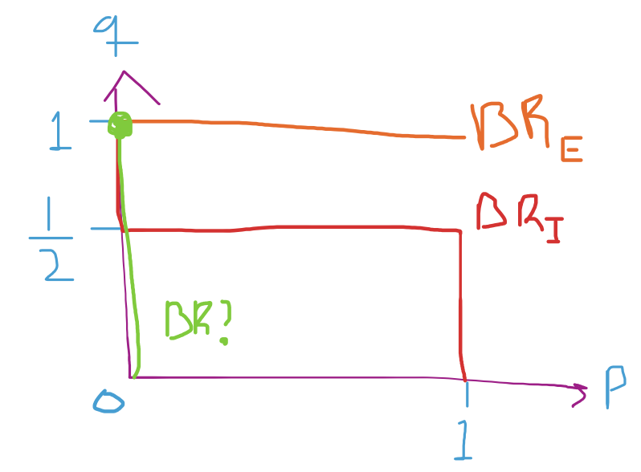
All the best responses are at $1,0$ thing. All three colors.

Bayesian games
A Bayesian (normal form) game is a collection $\left\langle N,Θ,ρ,A,u\right\rangle$ where
- type space $Θ≡Θ_{1}× . . . ×Θ_{n}$ specifies all possible types of players$i∈N$
- actual types are drawn from the joint probability distribution $ρ$ on $Θ$
- players’ (pure) strategy spaces $S_{i}$ are implicitly defined as the set of all functions $s_{i} :Θ_{i}→A_{i}$which map every possible type of player $i, θ_{i}$, to an action $s_{i}\left(θ_{i}\right)∈A_{i}$
(elements of Ai are strategies in the original game of incomplete information)
- $u_{i}$ is defined on $A×Θ_{i}$

- Common prior
Assume $\left\langle N,Θ,ρ,A,u\right\rangle$ is common knowledge. Assume all players have same beliefs about how types are distributed, so the common prior $ρ$.

Bayesian Nash equilibrium
A Bayesian Nash equilibrium (BNE) of the game $\left\langle N,Θ,ρ,A,u\right\rangle$ is a strategy profile $s^{⋆}=\left(s_{1}^{⋆},…,s_{n}^{⋆}\right)$ such that for any player $i∈N$ the strategy $s_{i}^{⋆}$ is a best response to $s_{-i}^{⋆}$ ie.
$$∀θ_{i}∈Θ_{i}:s_{i}^{⋆}\left(θ_{i}\right)∈A_{i} maximizes Eu_{i}\left(a_{i},s_{-i}^{⋆};θ_{i}\right)$$
(with expectation E based on $ρ\left(θ_{-i} | θ_{i}\right)$)

- Example 3
We have
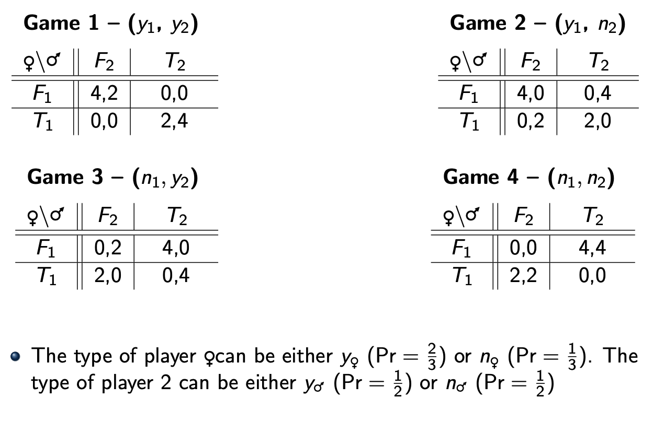
The woman’s type varies like blue, the mans like red. With the probabilities for their specific outcome written in orange, and the specific probability of each game written in green.
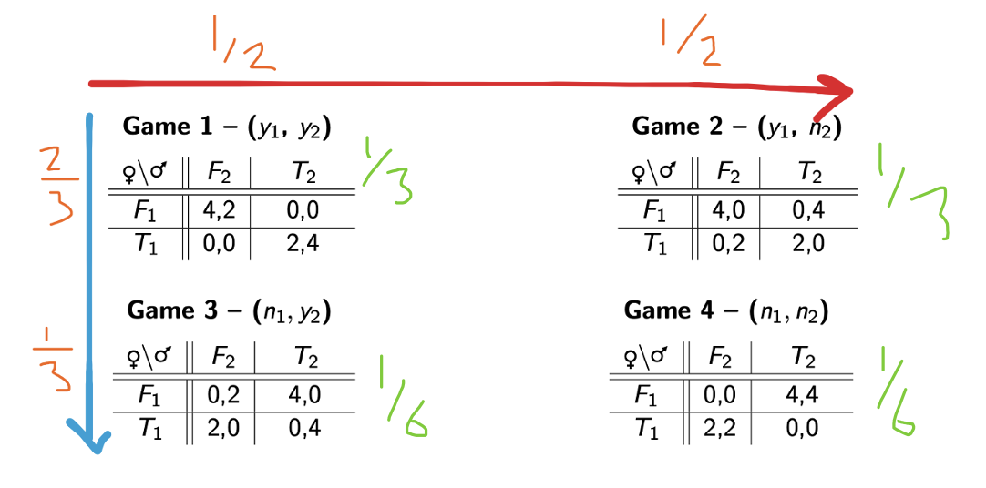
Now we will look at finding the equilibrium. So we need to find the best responses, so we need them to have a strategy for each type they can have.
We look at it if they are against the average opponent, so we need to calculate the average game.
They choose between football F and theater T.
We do this with all of them
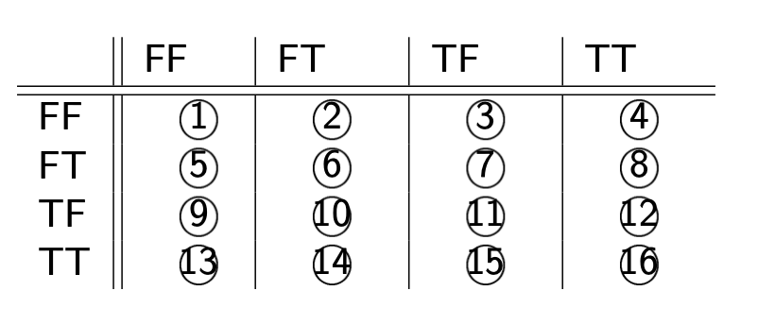
For the different games we get the payoffs
Woman / man | FF | FT | TF | TT
FF | $$\frac{8}{3}, ?$$
FT
TF |  | $$\frac{4}{3}, ?$$
TT
For the woman in FF/FF we have (purple in the drawing)
$$4·\frac{1}{3}+4·\frac{1}{3}+0·\frac{1}{6}+0·\frac{1}{6}=\frac{8}{3}$$
For the woman in TF/FT we have (green in the drawing)
$$0·\frac{1}{3}+0·\frac{1}{6}+2·\frac{1}{3}+4·\frac{1}{6}=\frac{4}{3}$$
So we would need to do this for all of them to fill it out, and for the man as well.
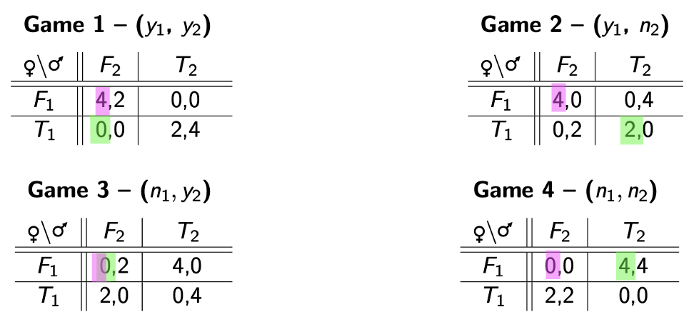
We do this for all.
One Bayesian equilibrium for the woman is $\left(FF;FT\right)$.

Purification of mixed strategies
If one player plays a mixed strategy, the other player is essentially not sure what they will play, incomplete information.
If we have the battle of the sexes game like this
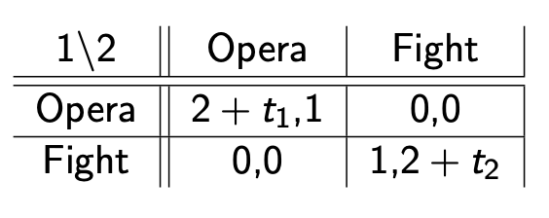
Then player 2 is not sure of player 1’s payoff, and not necessarily sure of what they would like to play. And the other way around.
Drawing of when they choose what depending on the cutoff value.
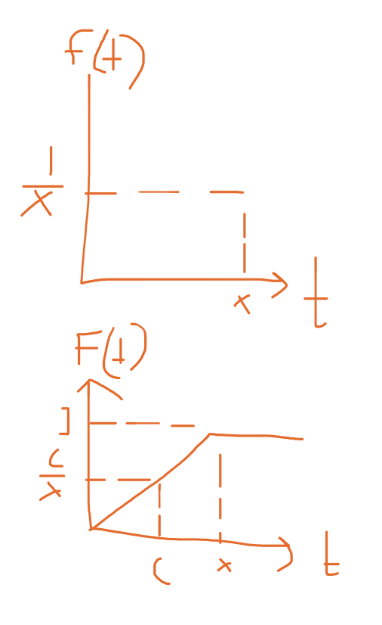

There are long calculations about this on slides…

Auctions
Good for multiple potential partners, short time frame, transparent.
English auction (open ascending-price auction)
Dutch auction (open descending-price auction)
Sealed-bid first-price auction: highest bidder wins, and pays that price
Vickrey auction (Sealed-bid second-price auction) highest bidder wins and pays second highest bids price.

the symmetric independent private values (SIPV) auction model: copied in
- A seller wants to sell a single unit of an indivisible object
- There are N potential buyers (= bidders) who have no budget constraints
- Bidder i’s respective value $x_{i}$ for the object is a random variable, distributed on$[0, ω_{i}]$
- Bidders’ valuations are private information
- All bidders’ values a priori are independent and identically distributed (= i.i.d.) with cumulative distribution function $F_{i}=F$ and density $f_{i}=f\left(thus, ω_{i}=ω\right)$
- A strategy for bidder i is a bidding function $β_{i}:\left[0,ω_{i}\right]→R_{+}$
- The seller is committed to the auction rules and has no special preference for any particular bidder We will additionally assume that all bidders and the seller are risk-neutral; in particular, bidder i gets utility $x_{i}-p$ if she wins at price p, and 0 if someone else wins

Second price sealed bid auction
The payoff of a bidder is then
$$Π_{i}=\left\{\begin{aligned}v_{i}-\max_{j≠i}{b_{j}}, if b_{i}>\max_{j≠i}{b_{j}} \\ 0, if b_{i}<\max_{j≠i}{b_{j}} \\ \frac{v_{i}-b_{i}}{\#highest bidders}, if b_{i}=\max_{j≠i}{b_{j}} \end{aligned}\right.$$
From class: (she drew it from home?)
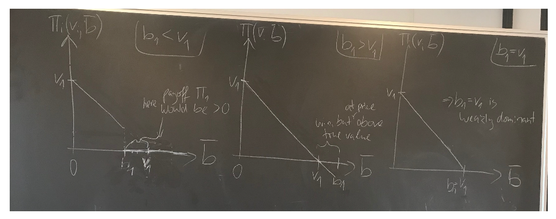
Where $\overline{b}$ is the highest bid among the others.
In the Vickrey auction what I say I am willing to pay is not what I actually pay.

Second price sealed bid auction - revenue
Each bidders valuation is uniformly distributed random variable $V_{i}\sim U\left[0,1\right]$.
Expected payment: for player 1(me)
$$Expected payment_{1}\left(v_{1}\right)=\operatorname{Pr}\left(win\right)·E\left[2nd highest bid | my bid is the highest\right]$$
$$=\operatorname{Pr}\left(win\right)·E\left[2nd highest bid | my valuation is highest\right]$$
$$=\operatorname{Pr}\left(v_{2}<v_{1}\right)·E\left[v_{2}|v_{2}<v_{1}\right]$$
$$=F\left(v_{1}\right)·\frac{1}{F\left(v_{1}\right)}·\int_{0}^{v_{1}}{f\left(v_{2}\right)·v_{2}dv_{2}}$$
We use conditional scaling here.
$\operatorname{Pr}\left(win\right)$ is the probability I win, so $\operatorname{Pr}\left(v_{2}<v_{1}\right)$
General formula
$$Expected payment_{i}\left(v_{i}\right)=\frac{1}{2}·v_{i}^{2}$$
So the expected revenue, total is
$$expected revenue=E\left[Expected payment_{i}\left(v_{i}\right)+Expected payment_{j}\left(v_{j}\right)\right]$$

First price sealed bid auction two bidders
Payoff of bidder:
$$Π_{i}=\left\{\begin{aligned}v_{i}-b_{i}, if b_{i}>\max_{j≠i}{b_{j}} \\ 0, if b_{i}<\max_{j≠i}{b_{j}} \\ \frac{v_{i}-b_{i}}{\#highest bidders}, if b_{i}=\max_{j≠i}{b_{j}} \end{aligned}\right.$$
Natural candidate for bidding function $b\left(v_{i}\right)=α_{i}·v_{i}$.
We expect that $α_{i}≤1$, so the only question is how much below will it be?
Bidder I’s expected payoff
$${\overline{u}}_{i}\left(b_{i},b\left(v_{i}\right)=α_{j},v_{j},v_{i}\right)=\frac{b_{i}}{α_{j}}·\left(v_{i}-b_{i}\right)$$
This comes because $v_{i},v_{j}\sim U\left[0,1\right]$.
The highest valuation our opponent can submit is $α=1$. Makes no sense to bid below 0 as then we will not win, and so
$$\frac{b_{i}}{α_{j}}∈\left[0,1\right]$$
This we can use to maximize the expected payoff and get the equilibrium strategy of
$$b_{i}=\frac{1}{2}·v_{i}$$
So $α_{i}=\frac{1}{2}$.
So in the two player game like this it is optimal to only bid half of your true evaluation.

In the general case the equilibrium bidding strategy is
$$b_{i}=\frac{N-1}{N}·v_{i}$$
Is best to do. So the more competition there is the closer you have to bid to your true evaluation.

The English auction is equivalent to a second price auction.
Japanese auction(leave when too expensive last person in the room pays what the last person to leave left for, so the price that made the second last person leave) so it is a second price auction.
Dutch auction is equal first-price sealed-bid auction.

Dynamic games of incomplete information
- Players may have incomplete information also in extensive games
- By the Harsanyi transformation, we can obtain a game of complete, but imperfect, information in which Nature moves first and assigns types to players according to probability measure $ρ$ on$Θ$
- At least two conceptual complications arise:
- If $θ_{i}$is private information, −i’s information sets are no singletons
⇒ there are no proper subgames started by −i’s moves
⇒ subgame perfection does not restrict −i’s moves off the NE path
⇒ sequentially irrational behavior (e.g. incredible threats) can survive
- While −i’s beliefs about $θ_{i}$ should be updated after any of i’s moves $a_{i}^{t}$, Bayes’ rule only defines the conditional probability $ρ(θ_{i} |a_{i}^{t} , θ_{-i})$ after moves ait which have positive probability under the equilibrium strategy profile $s^{⋆}$

Perfect Bayesian equilibrium PBE
A Perfect Bayesian (Nash) equilibrium (PBE) of a dynamic game of imperfect information is a combination$(s^{⋆},μ^{⋆})$of strategy profile $s^{⋆}= (s_{1}^{⋆},...,s_{n}^{⋆})$ and a system of beliefs $μ^{⋆} = (μ_{1}^{⋆},...,μ_{n}^{⋆})$ such that for any player $i∈N$
- strategy $s_{i}^{⋆}$ is sequentially rational under $μ^{⋆}$, i.e., it prescribes a best response to $s_{-i}^{⋆}$ in any information set $P^{j}∈P_{i}$ given the system of beliefs $μ_{i}^{⋆}$ , i.e.,
$$∀θ_{i}∈Θ_{i}:∀P^{j}∈P_{i}:s_{i}^{⋆}\left(θ_{i}\right)∈A_{i} maximizes E_{u_{i}}\left(a_{i},s_{-i}^{⋆} ,θ_{i} | P^{j}\right)$$
(with expectation E based on $μ_{i}^{⋆}$)
- system of beliefs $μ_{i}^{⋆}$ is consistent with $s^{⋆}$, i.e., it is derived from $s^{⋆}$ and Bayes’ rule (whenever it can be applied)

- Perfect Bayesian equilibrium PBE in words:
Requirement 1: Given their beliefs, the players’ strategies must be sequentially rational. That is, at each information set the action taken by the player with the move (and the player’s subsequent strategy) must be optimal given the player’s belief at the information set and the other players’ subsequent strategy (where a subsequent strategy is a complete plan of action covering every contingency that might arise after the given information set has been reached)
I Thus, players have beliefs and act optimally given these beliefs, but this is not enough to guarantee that these beliefs are reasonable. Hence we add another requirement to ensure reasonable beliefs, namely that players incorporate information in a correct statistical way:
Requirement 2: The players’ beliefs in every information set (on and off the equilibrium path) are determined by the players’ equilibrium strategies and Bayes’ rule whenever applicable

Bayes’ rule:
$$\operatorname{Pr}\left(A | B\right)=\frac{\operatorname{Pr}\left(A and B\right)}{Pr⁡(B)}$$

- Example 1 illustrating complication 1
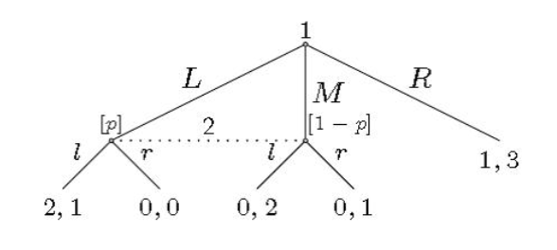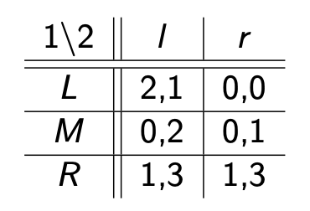
What to do?
There are the equilibria $\left(L,l\right)$ and $\left(R,r\right)$. They are both subgame perfect as there is only 1 subgame which is the whole game.
$\left(R,r\right)$ does not make much sense as player 2 would always play l no matter if plyer 1 plays L or M, so does not make much sense.

Continuation game: the last part of the game
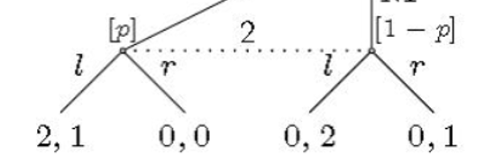
So it is about where he thinks he is.

Player 2 will always play l. L is BR of player 1, belief $\left[p\right]=1$ it has to be.
We include all this into the equilibrium subset(?) so $\left(R,r\right)$ does not seem like a reasonable equilibrium.
So $\left(L,l\right)$ is the perfect Bayesian equilibrium PBE together with $\left[p\right]=1$.

Perfect Bayesion equilibrium in example 1
In equilibrium $\left(L,l\right)$ player 2 belief must be $p=1$.
Player 2 will choose l if
$$1·p+2·\left(1-p\right)≥0·p+1·\left(1-p\right)⇒2-p≥1-p$$
So player 2 always will choose l.
If there is mixed strategy for player 1 with propability for L is $q_{1}$, for M is $q_{2}$ and R is $1-q_{1}-q_{2}$ then requirement 2 would forve player 2 belief of left node(so p) is
$$p^{⋆}=\frac{q_{1}}{q_{1}+q_{2}}=1$$
So it is still 1.

- Example 2 a card game
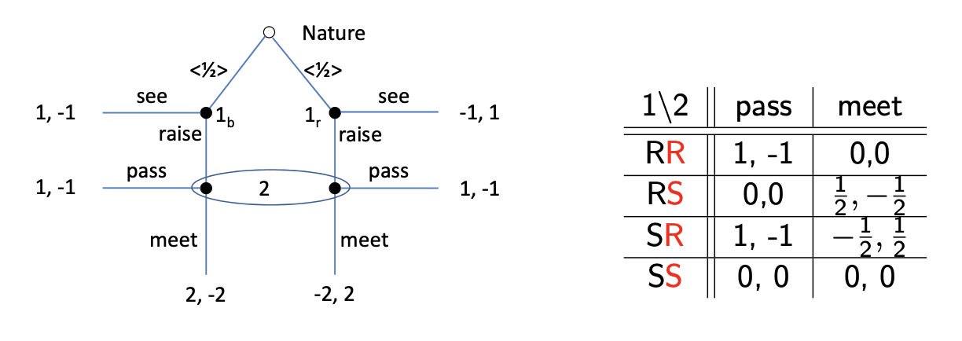
SS is strictly dominated by 50/50 mix of RR and RS.
Recast as dynamic game of incomplete information
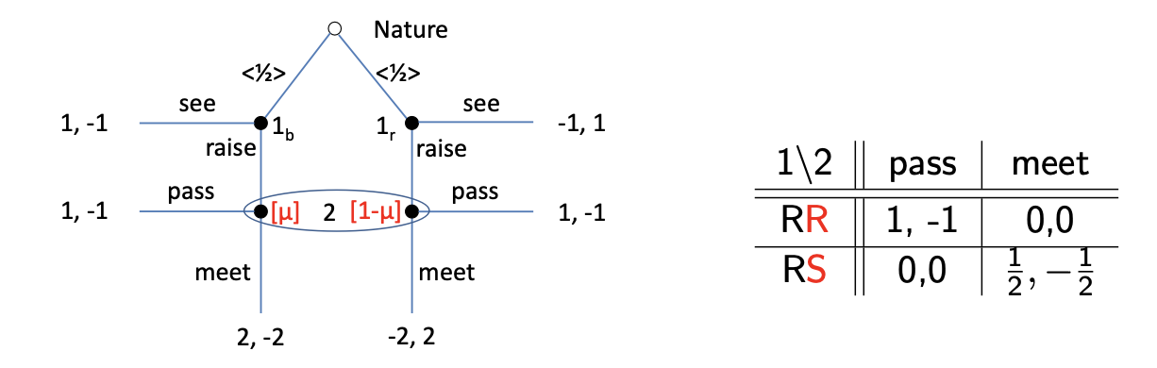
After he observes the raise he should update his belief.
So what should $μ$ be here in this game, so dependent on what he knows because player 1 choose to raise. So $μ>\frac{1}{2}$ specifically it is $μ=\frac{3}{4}$. we need consistency,
As in 3 out of 4 times when the other player raises he has the black card.
This is the update after player 1 raises.

$$μ=\operatorname{Pr}\left(black | info set is reached\right)=\operatorname{Pr}\left(black | reached\right)=\frac{\operatorname{Pr}\left(black∩reached\right)}{\operatorname{Pr}\left(reached\right)}=\frac{\frac{1}{2}·1}{\frac{1}{2}·1+\frac{1}{2}·\frac{1}{3}}=\frac{\frac{1}{2}}{\frac{4}{6}}=\frac{3}{4}$$
So we have the perfect Bayesian equilibrium here where player 1 places $\frac{1}{3}$ probability of the RR and $\frac{2}{3}$ on RS, and player 2 does pass with $\frac{1}{3}$ and meet with $\frac{2}{3}$ so we have
$$PBE:\left(\frac{1}{3}\left[RR\right],\frac{2}{3}\left[RS\right];\left(\frac{1}{3},\frac{2}{3}\right)\right)$$
With $μ^{⋆}=\frac{3}{4}$.
And that is what you need to write to write up a perfect Bayesian Nash equilibrium.

- Example 3 (illustrating complication 2)
We have the game tree:
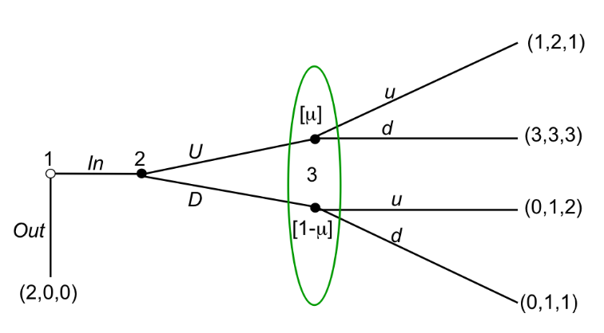

- Example 4 (illustrating complication 2)
Start backwards, assign beliefs in the last continuation game, the $μ_{2}$ and $1-μ_{2}$ beliefs player 2 (3?) has in his information set.
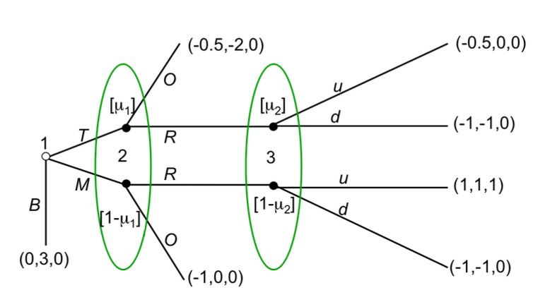
We start by assigning these beliefs, when would player 3 play “u”
$$0·μ_{2}+1·\left(1-μ_{2}\right)≥0$$
So this is just 0, so we learn that player 3 will always play u. this is for all $μ_{2}≤1$. but there is still a tiny chance that if he is certain he is in the top node then he is indifferent between u and d, he should not know and should play u, but if he for some reason thinks he is in the top node he is indifferent between the two as they both give him 0, he is indifferent if $μ_{2}=1$.
Now for player 2, if he expects the “u” from player 3. What does this imply for player 2? Consider a player 2 expecting “u” from player 3.
Play “R” if
$$μ_{1}·0+\left(1-μ_{1}\right)·1≥μ_{1}·\left(-2\right)+\left(1-μ_{1}\right)·0=EU_{2}\left(\text{"O"}\right)$$
So player 2 will always play “R” if he expects player 3 to play “u”.

- Example 5 (shows how to find PBEs)
We have
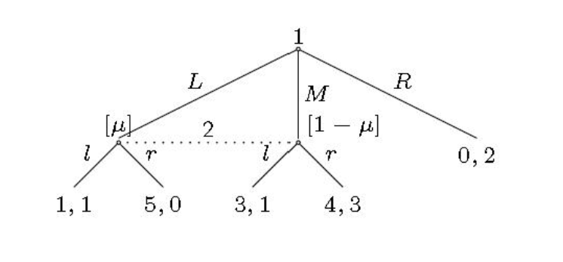

1\2 | $$l〈\frac{1}{3}〉$$ | $$r〈\frac{2}{3}〉$$
$$L〈\frac{2}{3}〉$$ | $$1,1$$ | $$5,0$$ | $$Δ1$$
$$M〈\frac{1}{3}〉$$ | $$3,1$$ | $$4,3$$ | $$Δ2$$

If player 1 anticipates player 2 playing l then player 1 would rather play M than L.

Signaling games
Equilibria in 2-types signaling games
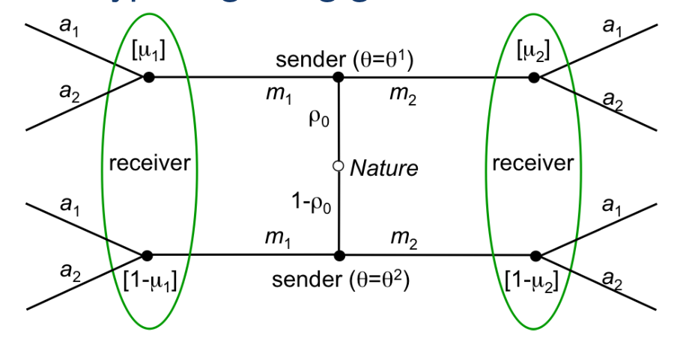

Example
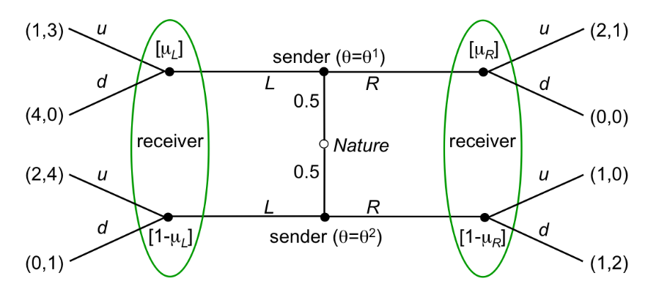

- Separation $\left(L,R\right)$
- Separation $\left(R,L\right)$
- Pooling on L
- Pooling on R

Now we look at the different options.
#1) Separation $\left(L,R\right)$
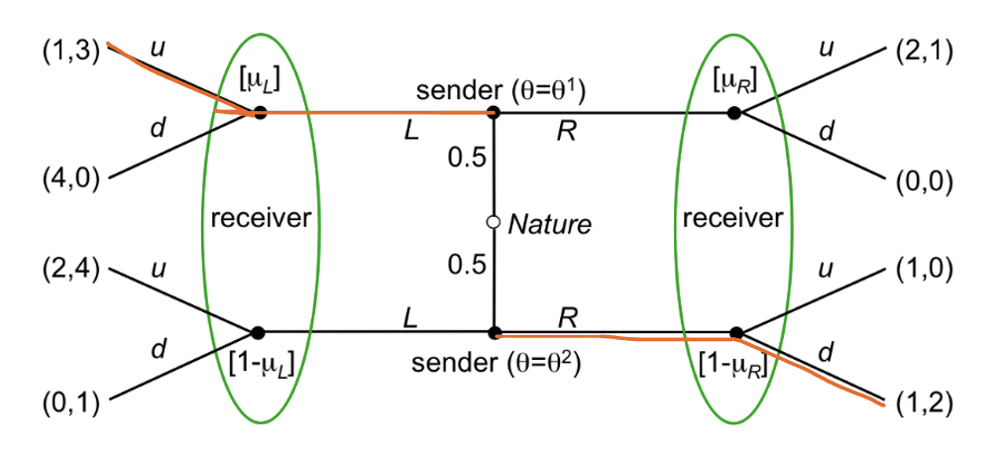
$$μ_{L}=1, μ_{R}=0$$
$$L→u, R→d$$
Are there incentives to deviate?
Type $θ_{1}$ has no incentive to deviate. Player 1(type $θ_{2}$) has incentive to deviate and play L if nature goes the down route as then player 2 plays u and so because 4 is higher than 2 he has incentive to deviate and there is no equilibrium.

#2) Separation $\left(R,L\right)$
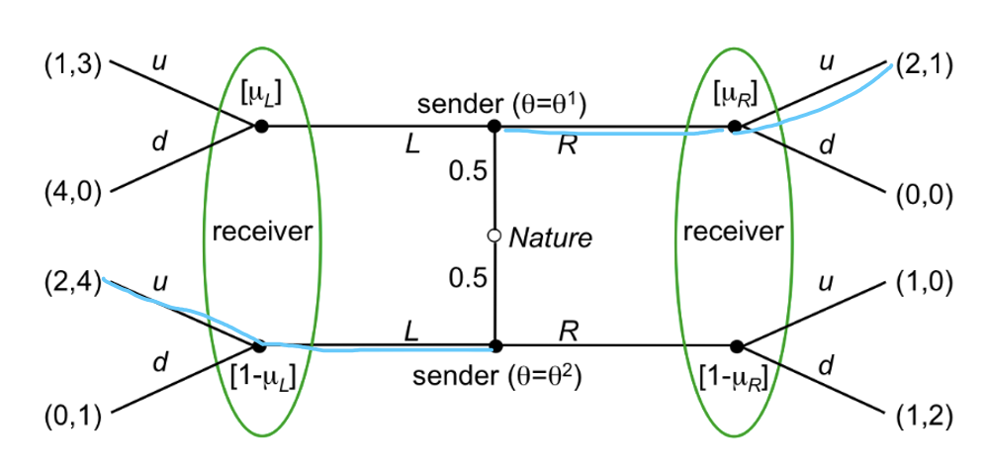
Is there incentive to deviate? There is no incentive to deviate, so it is an equilibrium.
Type $θ_{1}$ has no incentive to deviate.

#3) pooling on L
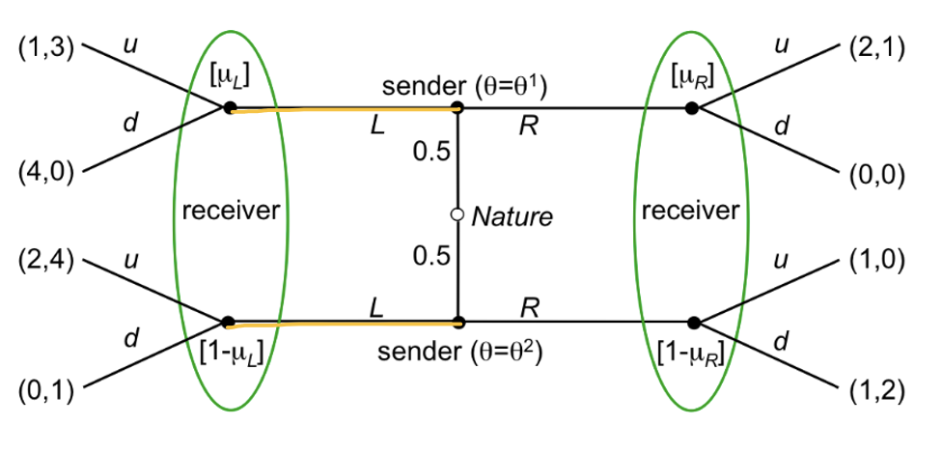
Now player 2 does not know which game they are playing, which L they are at so to speak. So $μ_{L}=0,5$. What is the best response of the receiver when getting the message L?
$$EU_{2}\left(u\right)=3·0,5+4·0,5=3,5$$
$$EU_{2}\left(d\right)1·0,5+0·0,5=0,5$$
So we will play u. type $θ_{1}$ sender gets the 1 at the top left, he can have incentive to deviate if the R message is answered by “u” the type $θ_{2}$ sender will not have incentive to deviate.
Make sure that receiver plays “d” after R to prevent type $θ_{1}$ from deviating. Now what is the belief? We choose a belief so that the receiver prefers d to u if
$$μ_{R}·0+\left(1-μ_{R}\right)·2≥2·μ_{R}+\left(1-μ_{R}\right)·0$$
If we solve we see that the receiver will prefer playing d over u if $1-μ_{R}$ is large enough. So $μ_{R}≤\frac{2}{3}$.

Further refinements
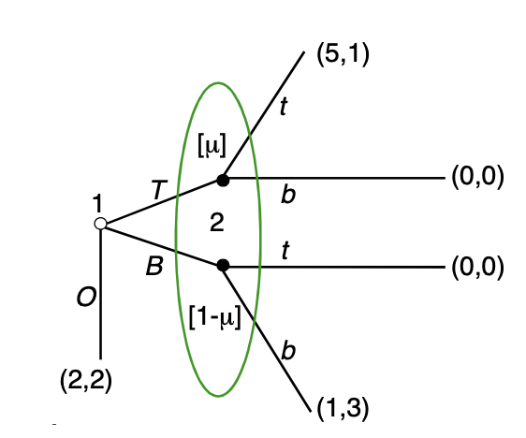
No proper subgames, inspect the game tree, and assign beliefs for the non singleton information set. What is the optimal behavior for player 2? He will play t if
$$1-μ≥3-3·μ⇒μ≥\frac{3}{4}$$
For Player 2 to play t.
If player 2 plays t what is the best response for player 1? Then he will play T. this gives us the first equilibrium. So $BR_{1}$ is T
If player 2 plays b instead then then the best response of player 1 is to play O. so $BR_{1}$ is O.
But this is not a good belief to have, makes no sense for player 1 to play B ever.
So we must have that $μ=1$.

- Dominance Criterion for PBE:
If possible, players’ off-equilibrium beliefs should place zero probability on nodes that are only reached if another player plays a strictly dominated action.

Example the Beer or Quiche game example of the $intuitive$ criterion
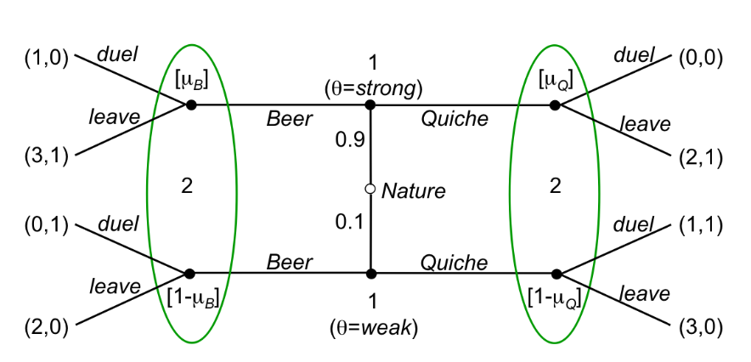
We have the different strategies:

- (Beer, Quiche)
So we have
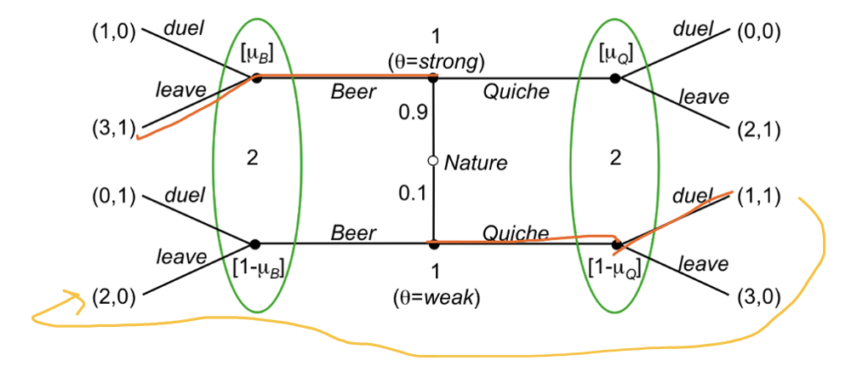

Is this an equilibrium?
There is initiative to deviate if the weak player instead chooses beer as then the other will choose to leave, and that is better for player 1.
It is not an equilibrium.

- (Quiche, Beer)

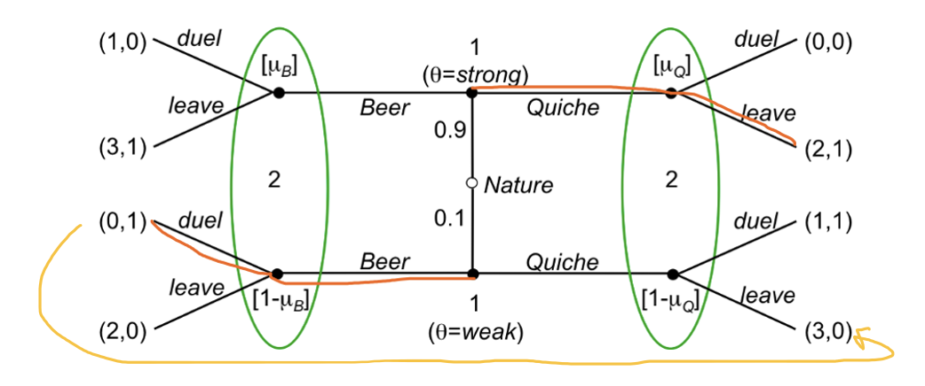
It is worth it here to play Quiche instead for the weak player 1 as then player 2 plays leave and player 1 gets a higher payoff.
It is not an equilibrium.

- (Beer, Beer) pooling on beer
This is an equilibrium
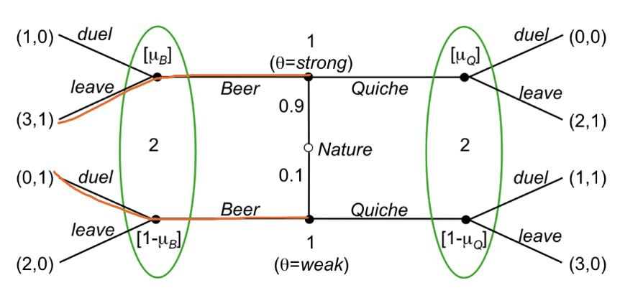
The strong type does not want to deviate. The weak type has incentive to deviate if the receiver leaves. So we need to prevent that to find an equilibrium. What do we need for player 2 to choose to fight, we need him to believe to be in the lower node so he chooses fight, this is when $1-μ_{Q}≥\frac{1}{2}$ then he will choose fight.
So when that is we have an equilibrium as then no one will want to deviate.

- (Quiche, Quiche) pooling on Quiche
We have
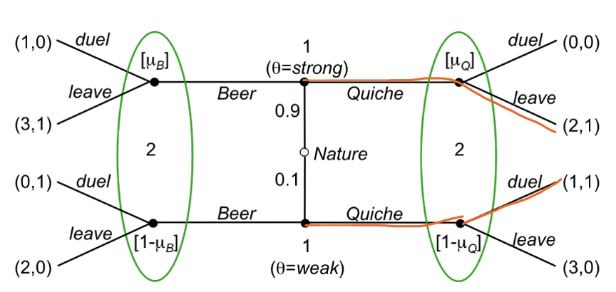

Want to deviate if the Beer signal makes the player 1 to want to deviate from Quiche, so we need player 2 to want to choose to duel, so he need to have a strong belief of player 1 being the weak type.
This is a pooling equilibrium, ${μ_{Q}^{⋆}}^{⋆}=0,9, {μ_{B}^{⋆}}^{⋆}=≤0,5$.
This is not a good equilibrium.

Intuitive Criterion for PBE in signaling games:
In a PBE $(σ^{⋆},μ^{⋆})$ there should not exist any sender type who would necessarily get more than his equilibrium payoff after choosing m if the receiver assigned probability zero to any type $θ∈J(m$).

Check steps on slides!

Application
We have the game tree:

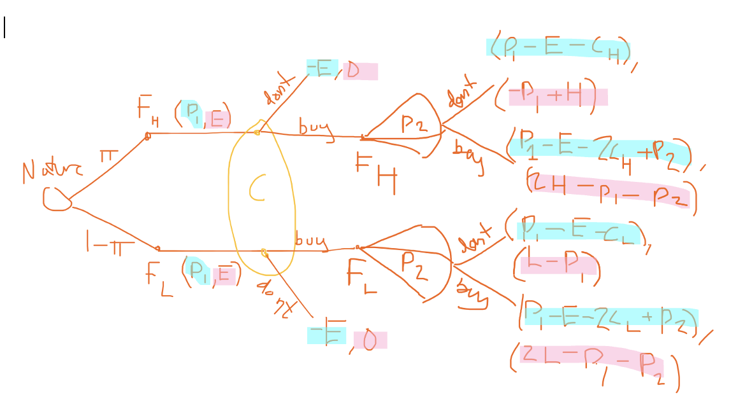
Where the blue are the payoffs for the firm, and the pink are the payoff for the consumer.
There is a lot of text about this on slides.

Firm type H
If it chooses $\left(p^{H⋆ },E^{⋆}\right)$ it’s profit is $p_{1}+p_{2}^{⋆}-2c_{H}$
If it chooses $\left(p,E^{⋆}\right)$ with $p<p^{H⋆}$ its profit is
If it chooses any other pair its profit is
Thus for equilibrium we need:

Check her slides

